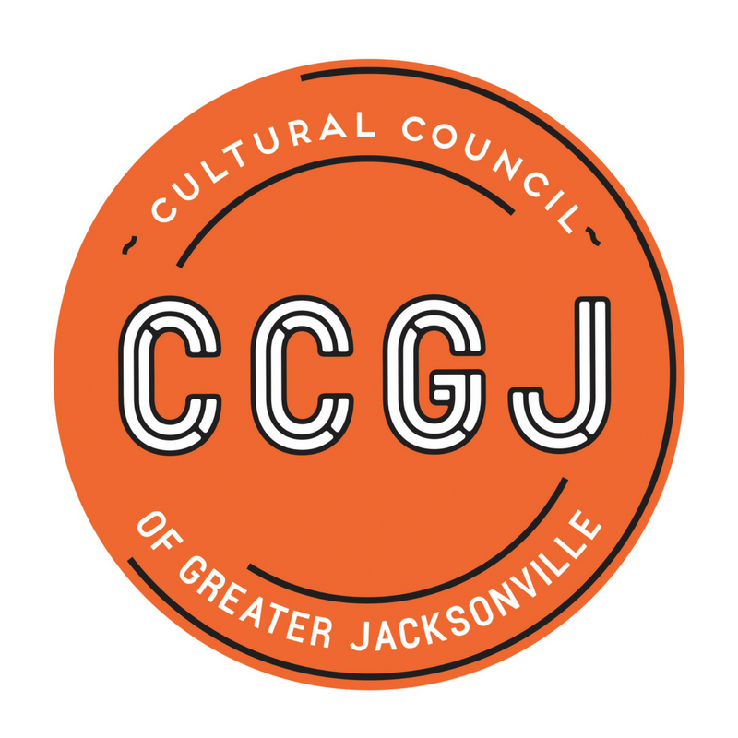
Cultural Council of Greater Jacksonville
Transition Team Minutes
July 30, 2018, 3:00pm
Times Union Center for the Performing Arts
300 Water St., Suite 201, Jacksonville FL 32202
Present
Board Members - Ann Carey, Bill Ferry, Claudia Baker, Dave Engdahl
Staff – Tony Allegretti

Discussion

Ms. Ann Carey, Transition Team Lead, called the meeting to order at 3;05 p.m.
Work continued on the Succession Planning Decision Template.
Actions:
- The next meeting will be scheduled and noticed for Thursday, August 16, 2018 after the Board Meeting from 2-3 pm.
Public Comment
No public comments were made.
Adjournment
The meeting was adjourned at 4:30pm.

