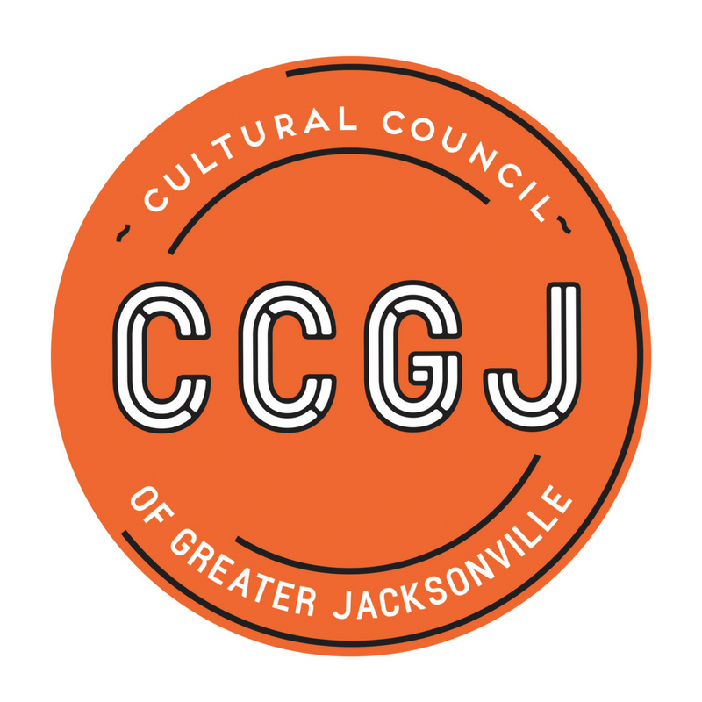
Cultural Council of Greater Jacksonville
Transition Team Minutes
July 16, 2018, 3:00pm
Times Union Center for the Performing Arts
300 Water St., Suite 201, Jacksonville FL 32202
Present
Board Members - Ann Carey, Bill Ferry, Claudia Baker, Dave Engdahl, Jannet Walker Ford
Staff – Tony Allegretti

Discussion
Ms. Ann Carey, Transition Team Lead, called the meeting to order at 3;05 p.m.
Discussion continued on the Succession Planning Decision Template and the job description provided by Mr. Dave Engdahl was discussed. The discussion turned to a risk assessment of the organization, both inward and outward facing.
Actions:
- Ms. Claudia Baker will document and send out the discussion regarding the organizational risk assessment as a white paper, to include: financial picture, lack of successor, lack of development skillset in board and staff, silos of APP and CSG organization (no cross-training), possibility for the need for an interim director.
- Ms. Carey will massage the job description per the discussion of the team and send it out to the team.
- The next meeting will be scheduled and noticed for Monday, July 30, 2018 from 3-5pm.
Public Comment
No public comments were made.
Adjournment
The meeting was adjourned at 5:10pm.

