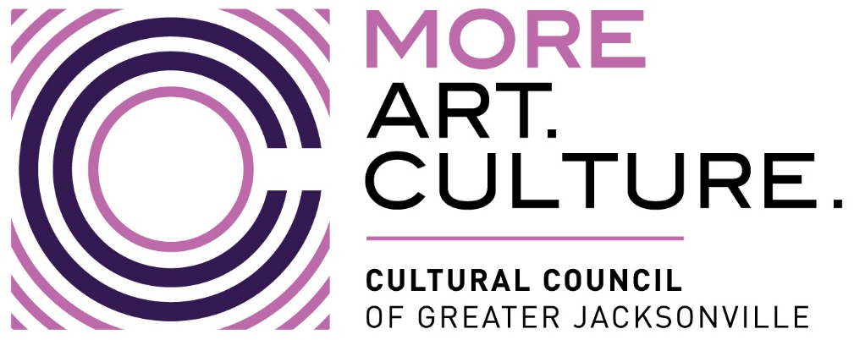
PUBLIC NOTICE
Cultural Service Grant Program Committee Hearing: 22-23 Capital Grants
HYBRID VIRTUAL/IN-PERSON MEETING NOTICE
Notice is hereby given that the Cultural Service Grant Program Committee will meet in a hybrid in-person/virtual meeting on Wednesday, April 12, 2023, at 9:15 AM. The public is invited to attend this meeting in-person at The Jessie Ball duPont Center at 40 East Adams Street, Room 208 (Second Floor) or via Zoom. Please see instructions on the following pages for details on accessing the meeting via Zoom.
Persons attending this meeting in-person or via Zoom will be given an opportunity to provide public comment during the designated public comment period. Interested persons who cannot attend the meeting either in-person or via Zoom, but who wish to submit public comments to be read during the public comment period of the meeting regarding any matter on the agenda for consideration at the meeting may do so by emailing John Poage no later than 5:00 PM the day before the meeting.
Pursuant to the American with Disabilities Act, accommodations for persons with disabilities are available upon request. Please allow 1-2 business days notification to process; last minute requests will be accepted, but may not be possible to fulfill. Please contact Disabled Services Division at: V(904) 255-5466, TTY(904) 255-5476, or email your request to karat@coj.net.
Please contact John Poage, by telephone at (904) 944-3609 or by email at John@culturalcouncil.org if you have any questions regarding this notice or if you experience technical difficulties during the meeting.

INSTRUCTIONS FOR PUBLIC TO ACCESS AND PARTICIPATE IN MEETING VIA ZOOM APPLICATION
1) If you have already registered for the Zoom application on your COMPUTER, enter this link in the address line for Google Chrome or Microsoft Edge Internet Browser: https://us06web.zoom.us/j/86546039419
Public Comment
- At the beginning of public comment, the Chair of the Cultural Service Grant Program Committee will establish a time period for each speaker that is no more than (3) three minutes per speaker.
- All participants who wish to participate in public comment during the meeting must log into Zoom with his/her full name.
- The Chair will only call on speakers using the “RAISE HAND” feature located within the Zoom app. Click on “Participants” button at the bottom of the screen and then scroll down and click on “Raise Hand.” You must have a microphone, video camera and speakers on your computer to participate with the “RAISE HAND” function.
- Wait to be recognized for your public comment time by the Chair
- Begin speaking after the Chair has recognized your turn during public comment
2) To access the meeting on Zoom through your COMPUTER if you have not registered for Zoom, follow these instructions:
- Sign up for the Zoom application by typing – Zoom.US – into Google Chrome or Microsoft Edge Internet Browser.
- Go to: JOIN A MEETING on Dash Board.
- Enter the Zoom Meeting ID: 865 4603 9419
Public Comment
- At the beginning of public comment, the Chair of the Cultural Service Grant Program Committee will establish a time period for each speaker that is no more than no more than (3) three minutes per speaker.
- All participants who wish to participate in public comment during the meeting must log into Zoom with his/her full name.
- The Chair will only call on speakers using the “RAISE HAND” feature located within the Zoom app. Click on “Participants” button at the bottom of the screen and then scroll down and click on “Raise Hand.” You must have a microphone, video camera, and speakers on your computer to participate with the “RAISE HAND” function.
- Wait to be recognized for your public comment time by the Chair
- Begin speaking after the Chair has recognized your turn during public comment
3) To access the meeting on Zoom through your TELEPHONE, follow these instructions:
- Dial +1 646 558 8656 US (EST). Find a local phone number via this link: https://us06web.zoom.us/u/kcu7i0DyCy
Enter the Zoom Meeting ID: 865 4603 9419
- If you join before the meeting has started, you will be prompted to press # to wait
- If you call using your mobile phone or device, you will be prompted to enter a unique participant ID. Press # to skip.
Public Comment
- At the beginning of public comment, the Chair of the Cultural Service Grant Program Committee will establish a time period for each speaker that is no more than (3) three minutes per speaker.
- The Chair will only call on speakers using the “RAISE HAND” feature located within Zoom. Enter *9 on the keypad of your telephone to activate the “Raise Hand” feature. Your phone must have a microphone and speakers to participate with the “RAISE HAND” function.
- Wait to be recognized for your public comment time by the Chair
- Begin speaking after the Chair has recognized your turn during public comment

