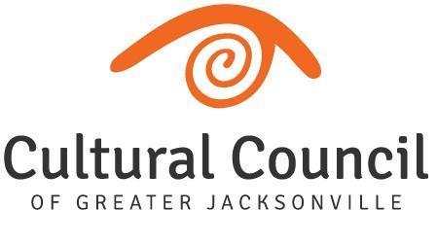

PUBLIC NOTICE
Cultural Service Grant Program Committee
IN-PERSON MEETING
Notice is hereby given that the Cultural Service Grant Program (CSGP) Committee will meet in-person on Thursday, June 2, 2022, at 9:00 AM, for the FY21-22 pilot Cultural Service Capital Grant committee orientation. This meeting will be held in The Jessie Ball duPont Center at 40 East Adams Street, Room 202 (Second Floor). The public is invited to attend this meeting in-person.
Persons attending this meeting will be given an opportunity to provide public comment during the designated public comment period.
Pursuant to the American with Disabilities Act, accommodations for persons with disabilities are available upon request. Please allow 1-2 business days notification to process; last minute requests will be accepted, but may not be possible to fulfill. Please contact Disabled Services Division at: V(904) 255-5466, TTY(904) 255-5476, or email your request to karat@coj.net.
Please contact John Poage, by email at John@culturalcouncil.org, or phone Iris Benson at (904) 358-3600, ext. 21 if you have any questions regarding this notice.

