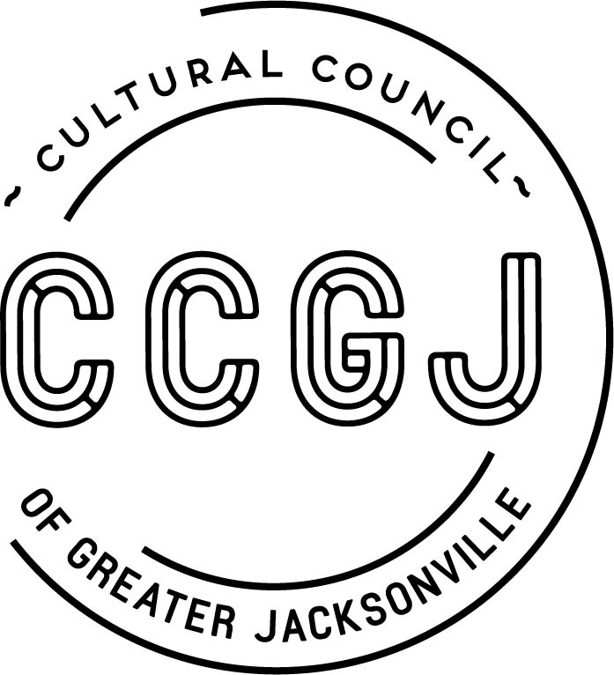

September 24, 2018

AMENDED

PUBLIC MEETING NOTICE

Notice is hereby given that the Cultural Council of Greater Jacksonville
Board of Directors will be meeting:

Tuesday, October 2, 2018
12:00-2:00 PM
Times Union Center for the Performing Arts
Cultural Council of Greater Jacksonville Conference Room
300 Water St.
Jacksonville, FL 32202

The purpose of this meeting is to review regular board business.

This is a public meeting and all interested persons are invited to attend. Please mark your calendars accordingly.

Pursuant to the American with Disabilities Act, accommodations for persons with disabilities are available upon request. Please allow 1-2 business days notification to process; last minute requests will be accepted, but may not be possible to fulfill. Please contact Disabled Services Division at: V(904) 630-4940, TTY-(904) 630-4933, or email your request to ADAAccommodationRequest@coj.net.

For more information contact the Cultural Council: (904) 358-3600.

cc: CCGJ Board of Directors/Staff
Cultural Service Grant Recipient Leadership
City Council Liaison
Media
Posted Notice Board – 1st Floor City Hall
Posted Notice Board – CCGJ Offices
CityC@coj.net

