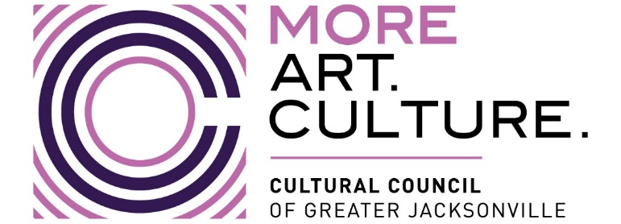
2022-2023 Cultural Service CAPITAL Grant Program Hearings
9:15 a.m.-Conclusion; Wednesday, April 12, 2023
MINUTES (pending approval)
Jessie Ball duPont Center, 40 East Adams Street in Conference Room 202
CSGP Members Present In-Person: Wilton Blake, Amy Crane, Cory Driscoll, Sally Pettegrew, Laura Schepis, Karen Estella Smith, Tim Snyder, Angela Strain, Ellen Williams (Chair); Members Present Online: NA
CSGP Members Absent: Alarie Gibbs
CCGJ Staff: Amy Palmer (Dir. of Grants Administration), John Poage (Grantmaking Manager), Diana Donovan (Executive Dir.), Josue Cruz (Dir. of Development), Iris Benson (Operations Coordinator)

Call to Order
Introductions and Opening Remarks
Hearings for CAPITAL GRANT Applicants:
- Beaches Museum
- Cummer Museum
- Florida Theatre
- Hope at Hand
- Jacksonville Arts & Music School
- Jacksonville Historical Society
- Jacksonville Symphony
- Mandarin Museum
- Museum of Contemporary Art – Jacksonville
- Museum of Science & History
- Players by the Sea
- Springfield Preservation & Revitalization Council
- The Florida Ballet
- The Jacksonville Children’s Chorus
- The Performer’s Academy
- Theatre Jacksonville
- WJCT
Public Comment
Final Scoring and Funding Allocation Recommendations for Capital Grant Applicants
Certification of Scores for Capital Grant Applicants
Final Public Comment
MOTION to approve and recommend the FY2023 Capital Grant Awards to the Cultural Council Board of Directors for its approval. Pettegrew, 2nd Strain (passed 9-0):
- “This motion includes a provision such that if an error is discovered during an audit of the scores following the hearings, then the correction of the error is provided for. Any such corrections will be communicated to both applicants and the committee.”
- “This motion includes a provision such that if an organization declines its award then those funds will be redistributed among the remaining grantees by re-running the iteration model.“
Closing Remarks & Adjournment

