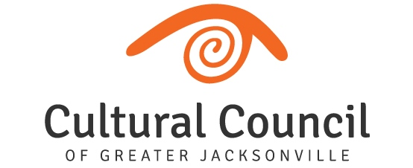

REVISED AGENDA (2)

2022-2023 Cultural Service Grant Program Hearings
Friday, Oct. 7 and Tuesday, Oct. 11, 2022
Room 208, 2nd Floor, Jessie Ball duPont Center

FUNDING LEVEL TWO

TUESDAY, OCT. 11 9 a.m. to conclusion

Timing of breaks will be at the discretion of the CSGP Committee Chair.

Call to Order

Introductions and Opening Remarks

Hearings for FUNDING LEVEL TWO Applicants:

- Art with a Heart in Healthcare
- (The) Jacksonville Children’s Chorus
- Theatre Jacksonville
- Springfield Preservation & Revitalization Council
- Players by the Sea
- Jacksonville Historical Society
- Jacksonville Arts & Music School
- (The) Florida Ballet
- Don’t Miss A Beat
- Beaches Museum and History Park
- Beaches Fine Arts Series

Public Comment regarding Funding Level Two Applicants

Final Scoring and Funding Allocation Recommendations for Funding Level Two Applicants

Certification of Scores for Funding Level Two Applicants

Final Public Comment

Closing Remarks

Adjournment

