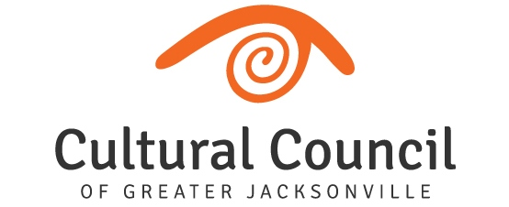

REVISED AGENDA (2)
2022-2023 Cultural Service Grant Program Hearings
Friday, Oct. 7 and Tuesday, Oct. 11, 2022
Room 208, 2nd Floor, Jessie Ball duPont Center

FUNDING LEVEL THREE

TUESDAY, OCT. 11 Hearings will commence following LEVEL TWO-conclusion

Timing of breaks will be at the discretion of the CSGP Committee Chair.

Call to Order

Introductions and Opening Remarks

Hearings for FUNDING LEVEL THREE Applicants:

LEVEL THREE – A (Currently-funded):

- Jacksonville Dance Theatre
- Ritz Chamber Players
- (The) Performer’s Academy
- Mandarin Museum and Historical Society
- Hope at Hand
- (The) 5 & Dime, A Theatre Company
- Deck the Chairs
- Civic Orchestra of Jacksonville
- Big Orange Chorus
- (The) Art Center Cooperative
- All Beaches Experimental Theatre

LEVEL THREE – B (New Applicant):
- Riverside Avondale Preservation

Public Comment regarding Funding Level Three Applicants

Final Scoring and Funding Allocation Recommendations for Funding Level Three Applicants

Certification of Scores for Funding Level Three Applicants

Final Public Comment

Closing Remarks & Adjournment

