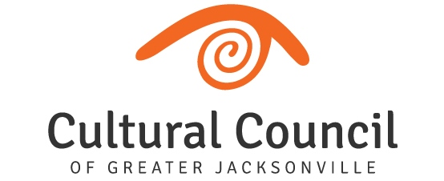

REVISED AGENDA (2)

2022-2023 Cultural Service Grant Program Hearings
Friday, Oct. 7 and Tuesday, Oct. 11, 2022
Room 208, 2nd Floor, Jessie Ball duPont Center

FUNDING LEVEL ONE

FRIDAY, OCT. 7 1:30 p.m. until conclusion

Timing of breaks will be at the discretion of the CSGP Committee Chair.

Call to Order

Introductions and Opening Remarks

Hearings for FUNDING LEVEL ONE Applicants

- WJCT Public Broadcasting
- Museum of Science and History
- Museum of Contemporary Art - Jacksonville
- Jacksonville Symphony Association
- Florida Theatre
- Cummer Museum of Art and Garden
- Cathedral Arts Project

Public Comment regarding Funding Level One Applicants

Final Scoring and Funding Allocation Recommendations for Funding Level One Applicants

Certification of Scores for Funding Level One Applicants

Final Public Comment

Closing Remarks

Adjournment

