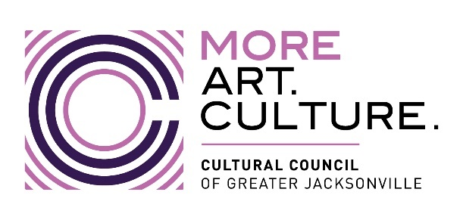

AGENDA
2022-2023 Cultural Service CAPITAL Grant Program Hearings
*9:15 a.m.-Conclusion; Wednesday, April 12, 2023
Room 208, 2nd Floor, Jessie Ball duPont Center
**REMOTE OPTION (FOR APPLICANTS ONLY)

Call to Order

Introductions and Opening Remarks

Hearings for CAPITAL GRANT Applicants:

- Beaches Museum
- Cummer Museum
- Florida Theatre
- Hope at Hand
- Jacksonville Arts & Music School
- Jacksonville Historical Society
- Jacksonville Symphony
- Mandarin Museum
- Museum of Contemporary Art – Jacksonville
- Museum of Science & History
- Players by the Sea
- Springfield Preservation & Revitalization Council
- The Florida Ballet
- The Jacksonville Children’s Chorus
- The Performer’s Academy
- Theatre Jacksonville
- WJCT

Public Comment

Final Scoring and Funding Allocation Recommendations for Capital Grant Applicants

Certification of Scores for Capital Grant Applicants

Final Public Comment

Closing Remarks & Adjournment

*Timing of breaks will be at the discretion of the CSGP Committee Chair.

**REMOTE PARTICIPATION OPTION (APPLICANTS ONLY):

Join Zoom Meeting:
https://us06web.zoom.us/j/86546039419
Meeting ID: 865 4603 9419
Onetap mobile
+13052241968,,86546039419#US
+13092053325,,86546039419#US
Dial by your location
+1 305 224 1968 US
+1 309 205 3325 US
+1 312 626 6799 US (Chicago)
+1 646 558 8656 US (New York)
+1 646 931 3860 US
+1 301 715 8592 US (Washington DC)
+1 669 444 9171 US
+1 689 278 1000 US
+1 719 359 4580 US
+1 720 707 2699 US (Denver)
+1 253 205 0468 US
+1 253 215 8782 US (Tacoma)
+1 346 248 7799 US (Houston)
+1 360 209 5623 US
+1 386 347 5053 US
+1 507 473 4847 US
+1 564 217 2000 US
Meeting ID: 865 4603 9419
Find your local number: https://us06web.zoom.us/u/kcu7i0DyCy

