Executive Director Report
4/19/2018

Has it only been two months since our last board meeting? It seems like forever. With so many events and activities, things that just happened a few weeks seem like last year. I’ll make this update in segments. Of course I’ll give in-person updates at the meeting itself.

Floyd Norman

What a legend! Thank you to those of you who could make this Vystar sponsored lecture and Master Class. Floyd and Adrienne had an amazing time in Jacksonville and they provided an evening of education, history, and entertainment. Floyd is only 82 years old and he is so very sharp and funny and talented, one could see how he has built a fantastic career in the animated arts. More than 200 people attended our event and nearly that many were able to meet Floyd and Adrienne afterwards. They’ve stated that Jacksonville is in their top 3 communities they have visited. Floyd and Adrienne are always on the move, so that is high praise. An excellent evening indeed. Next up, Deanna Haggag from United States Artists. You can get your tickets now.

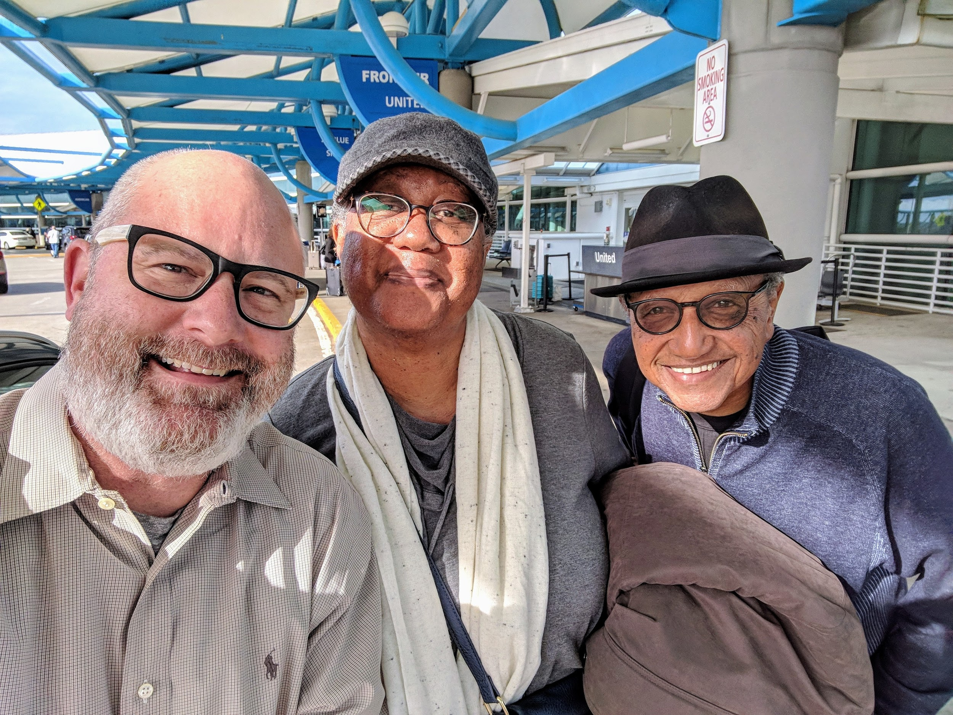
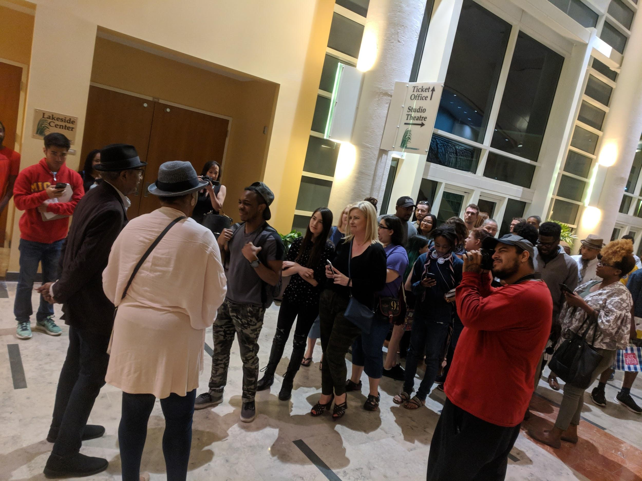

Public Art Week

I’m sure that we’ll hear about Public Art Week a few times at this board meeting so I’ll keep it brief. With nearly 30 events all over this city, Public Art Week is now firmly in the category of a signature Jacksonville cultural event. For me the best parts were the outstanding support from neighborhoods and civic organizations that are leading the way for collaboration and community building through art and specifically through art that the entire community can enjoy. Huge thank you to title sponsor JEA whose sponsorship really allowed us to upgrade events and market to a much wider audience than before. The Regions sponsored luncheon on private sector investing in the arts was a sell out and our panel moderator Emily Peck from American’s for the Arts was a fantastic addition to a great crowd gathered at Jacksonville University. This luncheon will forever be known as the one where the CEO of the largest employer in Jacksonville (Hugh Greene, Baptist Health) said emphatically that the city needed to invest more in the arts. That was followed up by a commitment of just that by Councilman Jim Love. The multitude of events were captured as usual by Patrick’s expert photography. Many community members were able to hold up signs that said what community means to them or one thing that can that they can do to build a better community. Be sure to check out all of these great photos at our social media channels.

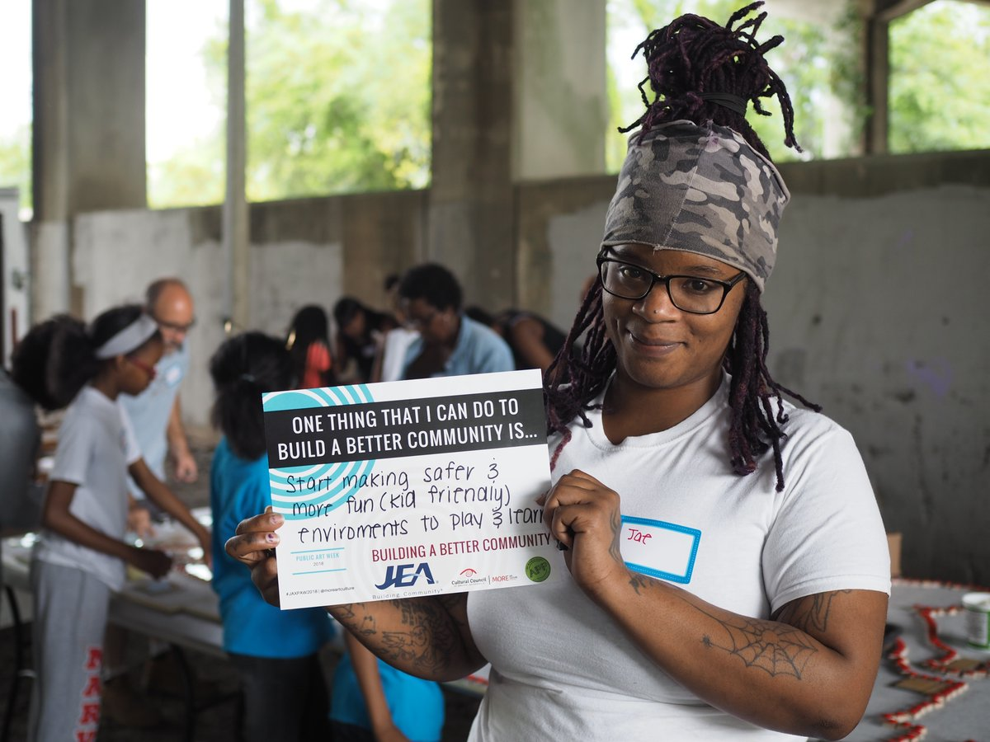

LaVilla Jazz & Heritage Festival

This first time jazz festival that could is shaping up to be a really fun event. We’ve been working hard with the Durkeeville Historical Society and the Jazz Discovery Series to bring the community out to remember the rich history of the LaVilla neighborhood at the site of the birth of two of Jacksonville’s most influential natives. Our goal of creating a sense of place at Lift Ev’ry Voice and Sing Park will be met with great jazz, hot food and cool beverages. Proceeds from the event will help support the park and future art and amenities on the site. Please join us Sunday for a relaxing free jazz fest that is sure to make you smile.
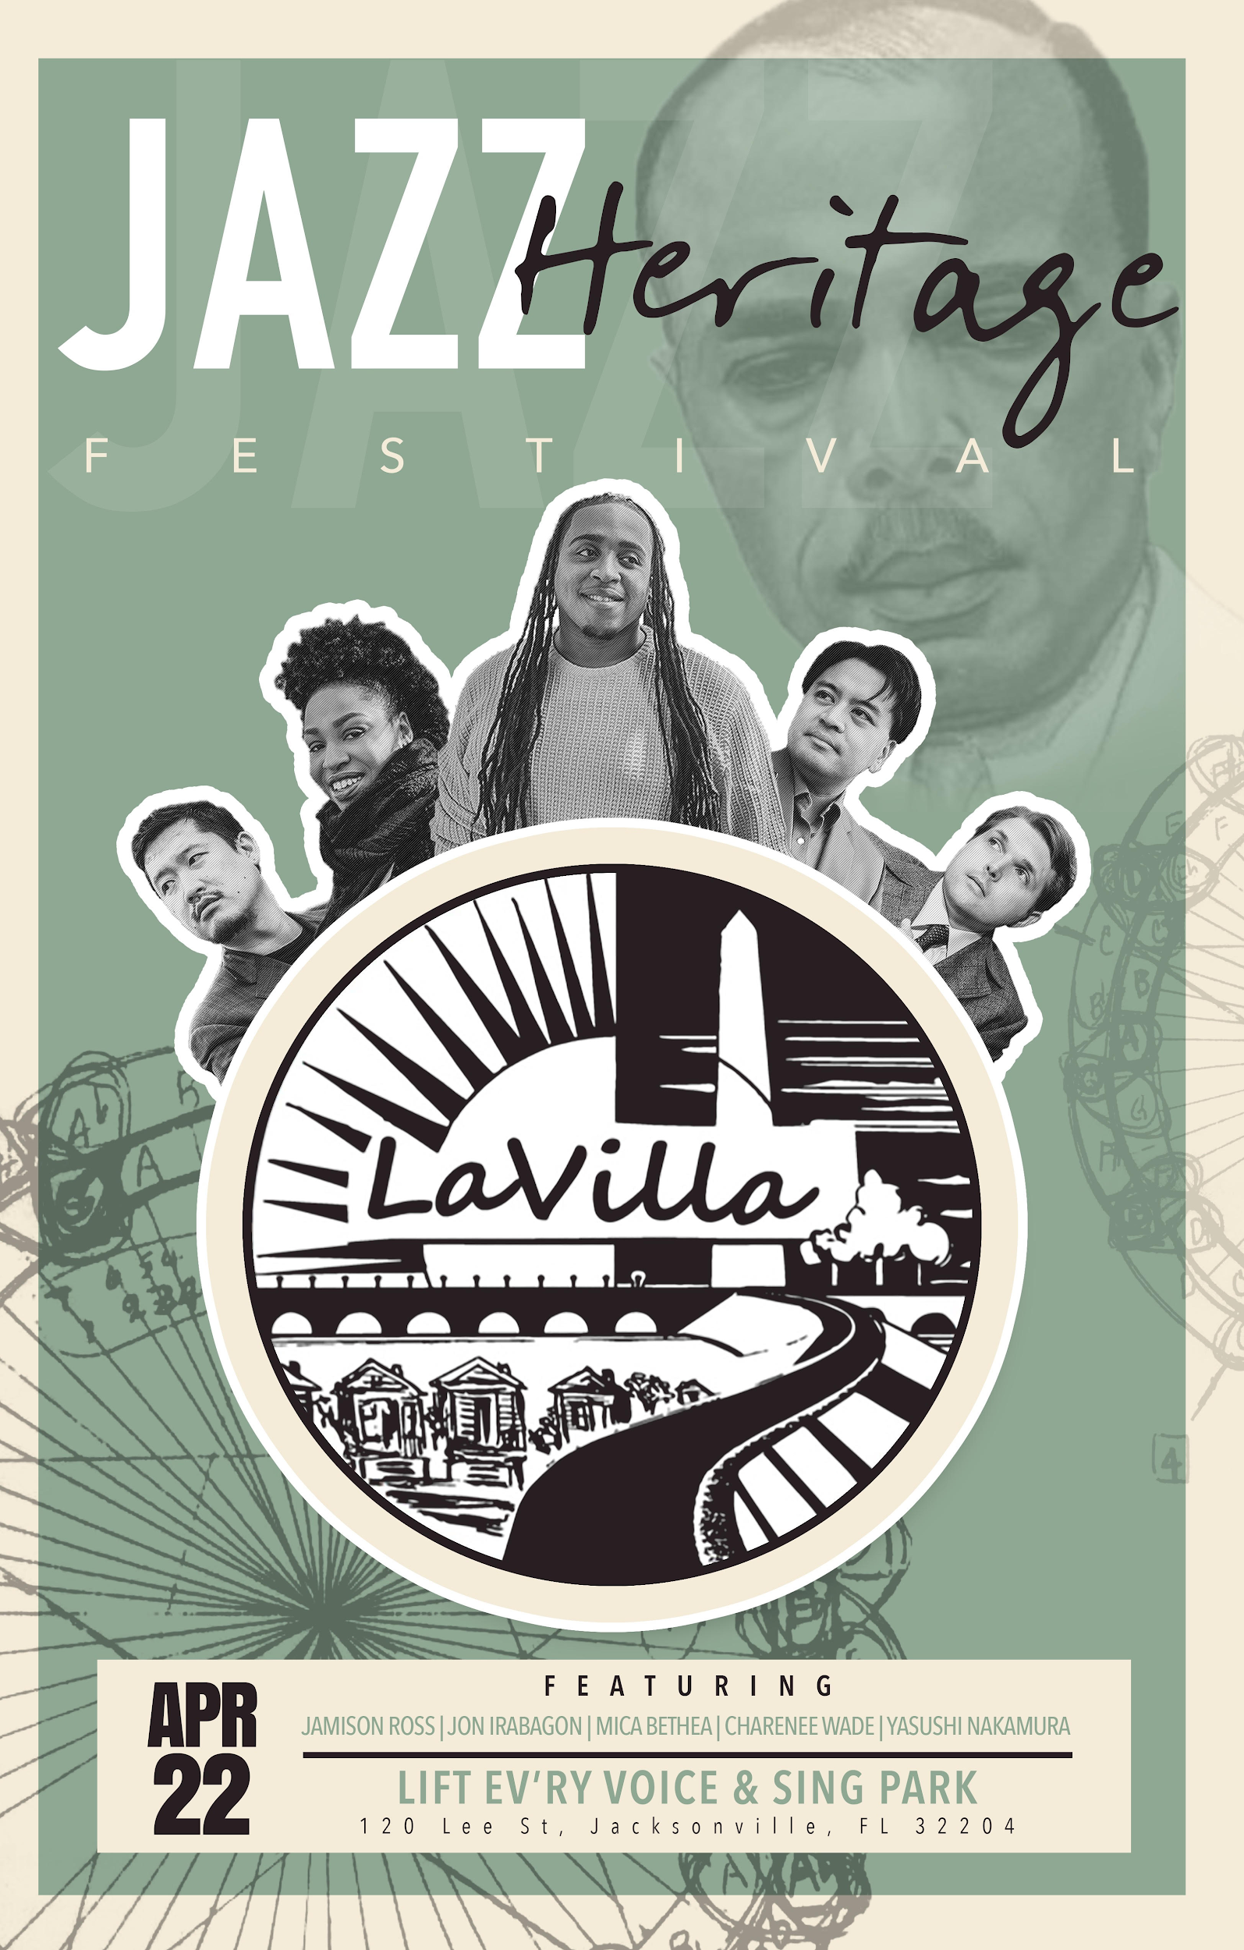

Advocacy

Advocacy season runs from January to December. We’ve been working hard with our CSG partners to collect stories and data to make a case for increased funding for the CSG program. To date more than 100 stories of how arts and culture has increased the quality of life have poured in from all over Jacksonville. We are delivering these as well as new data on the economic impact of the arts to our elected officials. You’ll see more activity in this regard between writing this and the board meeting because our annual Return on Investment Survey is due April 15. State funding has decreased from the high of $150,000 in 2015 to $9,600 in 2018. The Cultural Council scores very high on this grant is always eligible for full funding but it is clear we cannot plan or count on state funding. This makes advocacy at the city level even more crucial as many of our CSGs also rely on state funding. CSG funding hasn’t caught a break in a long time. I’ll go into more detail of how we are delivering information to our elected officials in person at our meeting.

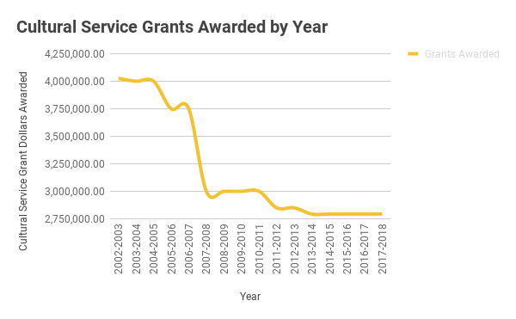

Arts Awards

Our change to a seated dinner at TIAA Bank field has been running smoothly. We have a great line-up of artists, a fantastic menu and excellent nominations for awards. American poet and playwright and award winning journalist Al Letson will emcee and we’ll all have table service and be able to enjoy and hear the program without difficulty. The art installation by Castano Group is the largest in our history and will be worth the ticket itself. Please, please by your tickets soon and convince everyone you know to support our programs and organization by coming to this amazing event. They’ll regret not making this one, otherwise.

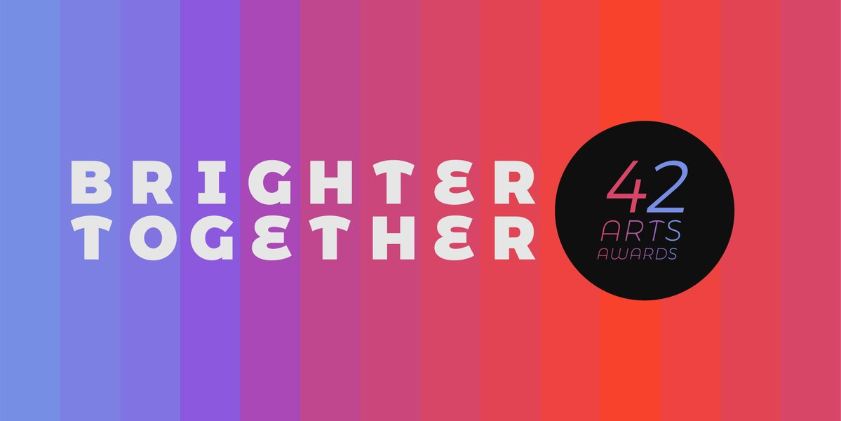

Human Resources

Just a note that I believe strongly in our staff and family. In addition to the somewhat recent addition of health, vision, dental, life insurance, we’ve added short and long term disability. Now if I could get people to start taking their PTO, we’d be cooking.

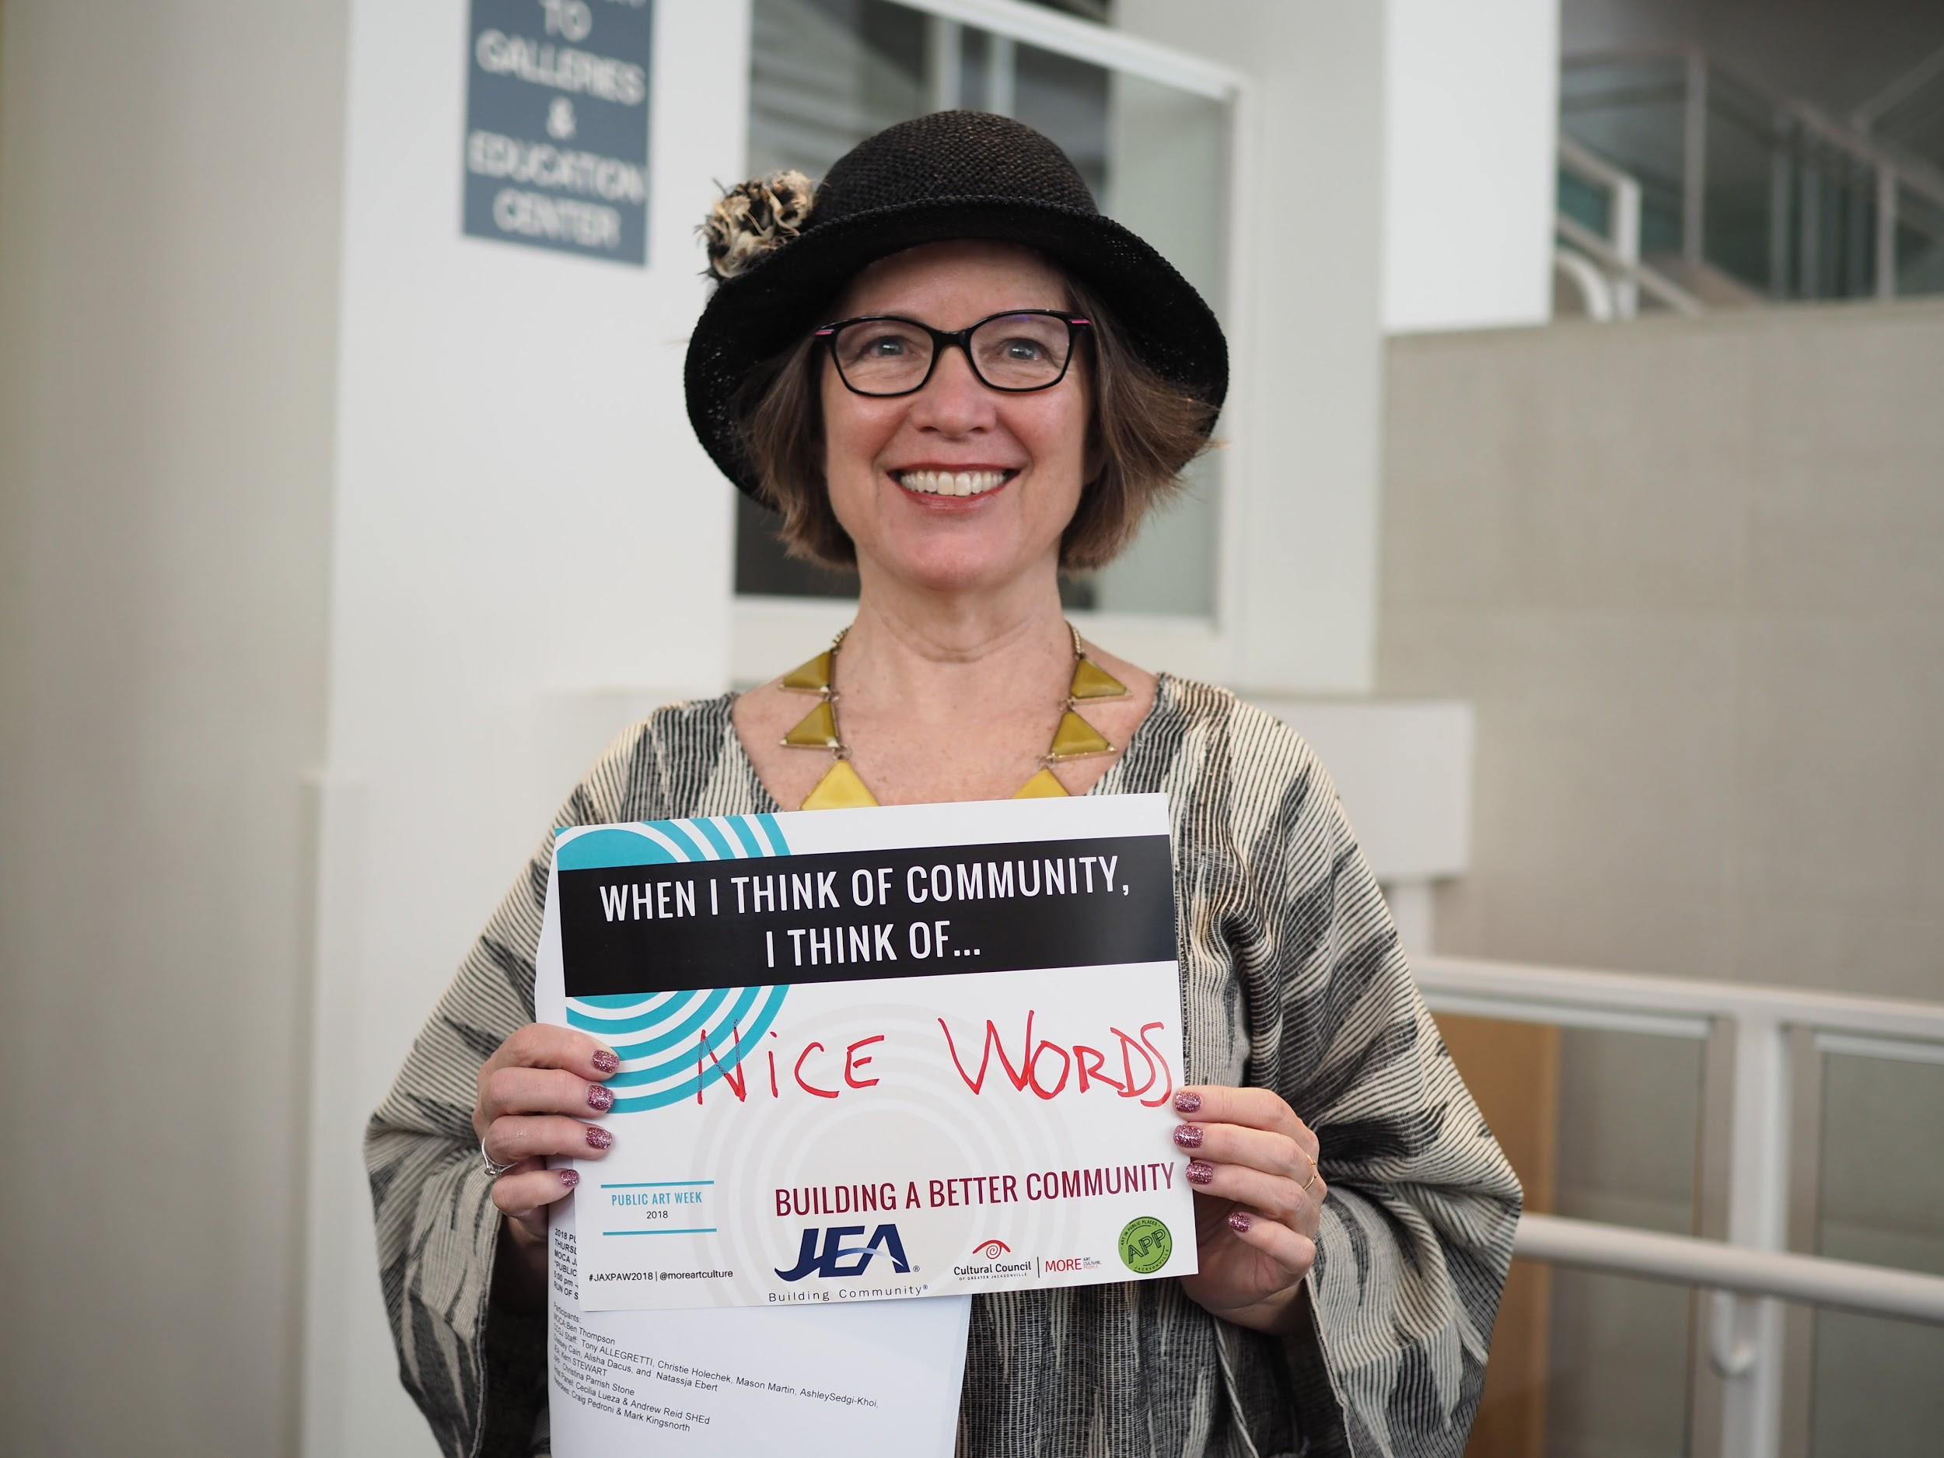

As always, the doors always open.

Thanks, Tony

