FOR IMMEDIATE RELEASE
The Cultural Council of Greater Jacksonville
Ashley Wolfe, Public Art Program
Ashley@culturalcouncil.org | 904-962-6201

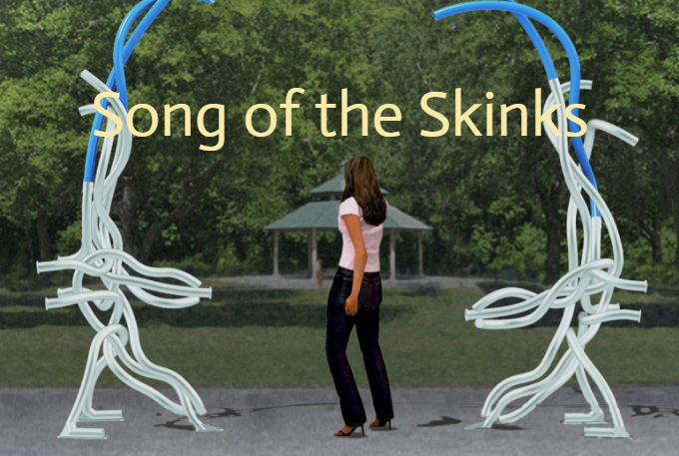

SKINKS, MUSICAL INSTRUMENT, OR INTERACTIVE SCULPTURE?
New City of Jacksonville Public Art

SONG OF THE SKINKS
Dedication
Artist, Naturalist, UNF Music Students and City Councilmembers
11:00 AM
Friday, October 2, 2020
Cuba Hunter Park. Entrance at 3540 Bedford Rd

Sculpture Installation by Artist Matt Babcock
10 AM to 5 PM, Thursday October 1, 2020

The Art in Public Places program of the City of Jacksonville dedicates the first in a series of new public art in Jacksonville neighborhoods. The in-person and online dedication will start at 11 AM on October 2nd at the Cuba Hunter Park with its entrance at 3540 Bedford Rd. The interactive sculpture, created by Seattle-based public artist Matt Babcock, was designed to be a playful representation of a series of blue-tailed skinks, a lizard native to Florida.

The sculpture is not only visual, but also musical. The many pipes were created on a special machine in Japan that allows hard materials to be bent into curved shapes. Each pipe resonates a musical note when struck with a hand or flip-flop. The interactive instrument is accessible to anyone and any age.

The sculpture is Matt Babcock’s first sculpture east of the Mississippi. Babcock is known for playful work that has a wide range of appeal and for his determination to respond to the community. Babcock was especially taken by creatures inhabiting the park, the international character of the surrounding community with many spoken languages and the local athletes using wheelchairs. Nature and music bridge all gaps among the different park users. The site of the sculpture was selected with a wide concrete zone for wheelchair accessibility and near the play area for families.

The project’s budget of $40,800 was generated by CIP dollars allocated from the park’s construction. To develop the design for the sculpture, Babcock worked with key stakeholders such as Cuba Hunter Park visitors and staff, Brooks Rehabilitation Adaptive Sports and Recreation, Lutheran Social Services, the City’s Parks Department, and current and former Councilmembers LeAnna Cumber, Lori Boyer and Suzanne Jenkins. Ashley Wolfe managed the art project for the Cultural Council.

The artist Matt Babcock will join the Art in Public Places committee for the October 2nd dedication, as well as UNF music students who will demonstrate the sculpture’s musical qualities, area City Councilmember LeAnna Cumber, and a naturalist who will tell a little bit about the blue tailed skink.

In the next few months, the new City public art projects will be installed by the City in Northwest Jacksonville and artists will be selected for artworks in San Marco and Mandarin

For more information about the event see: https://www.facebook.com/events/643549426600466

For more information about the artist and artwork see:
https://www.culturalcouncil.org/cuba-hunter-park-neighborhoods-public-art-project.html

The Cultural Council of Greater Jacksonville’s mission is to enrich life in Northeast Florida by investing in arts and culture. They serve as the official regranting and administrative agency for City of Jacksonville funding to arts and cultural organizations, as well as provide several programs that benefit artists and arts and culture organizations of all disciplines.





