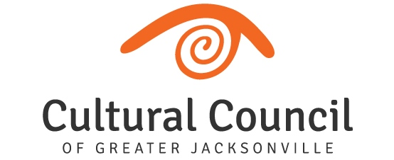

CULTURAL COUNCIL BOARD OF DIRECTORS - GRANT REPORT
August 20, 2020

2020-2021 CULTURAL SERVICE GRANT PROGRAM
New appointments and reappointments to the CSGP Committee that had been held up due to the pandemic will now be considered at the August 18 City Council Rules Committee meeting.
The 2020-2021 CSGP Committee is now hard at work conducting site visits and evaluating applications for 30 applicants to the Cultural Service Grant Program (26 operating and four program). Public hearings will be held September 30 and October 1. This year’s committee members include:
Kenyon Merritt – Chair
Board Reps:
- Diana Donovan
- David Faliszek
- Sandra Hull-Richardson
Community Reps:
- Truitte Moreland
- Sally Pettegrew
- Ben Rubin
- Karen Estella Smith
- Angela Strain
- Kedgar Volta
- Ellen Williams
COJ Updates
- CSGP - Emergency Legislation Status
  - Sponsored by C.M. Michael Boylan, emergency legislation has passed City Council and awaits the Mayor’s signature. The legislation will assist CSGs and program grantees impacted by COVID by loosening matching requirements and extending deadlines for expenditure of funds and related reporting.
- COJ CARES
  - The majority of the Cultural Service Grantees, as well as, the Cultural Council applied for and received funding through COJ CARES through two rounds of funding to help replace income lost due to the pandemic. C.M. Michael Boylan was instrumental in the inclusion of nonprofits for this federal relief funding administered by the city of Jacksonville.
- CSGP Funding
  - The Mayor’s budget recommends level funding for CSGP, which would preserve the 7% increase achieved for 2019-2020. The budget item was considered without comment during the City Council Finance Committee budget hearings on August 7.
PNC – Grant for Art Works
Thanks to funding from the PNC Foundation, the Cultural Council is developing a new grant program for individual artists. The Grant for Artists Works will support the creation of new works within today’s social environment. The purpose of the grant is for artists to create a new work or presentation of free and accessible on-line arts-based experiences, learning opportunities or a service to audiences across Jacksonville - and beyond – during the pandemic. Grant awards will be $1,000 each.

.

