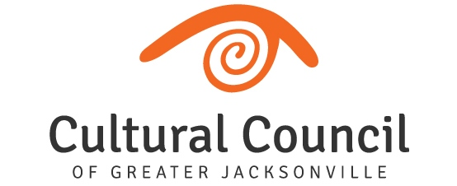

CSGP Committee Report
August 15, 2019

- The CSGP Committee is currently busy conducting on-site visits with their assigned applicants and reviewing and scoring the 27 applications.

- 2019-2020 CSGP Hearings are scheduled for Wednesday, Sept. 25 and Thursday, Sept. 26 in the Davis Gallery of the Times-Union Center for the Performing Arts. Proceedings will begin at 9 a.m. on both days. As always, board members are encouraged to attend.

- At its next meeting on Oct. 17, the Cultural Council Board of Directors will be asked to move to approve the CSGP Committee’s Cultural Service Grant award recommendations.

- One board member opening on the Cultural Service Grant Program Committee for the 2020-2021 process is anticipated. If you have a particular interest in serving on this committee, please contact Amy Palmer. Please note that board members may not serve on the Art in Public Places Committee and the CSGP Committee at the same time.

