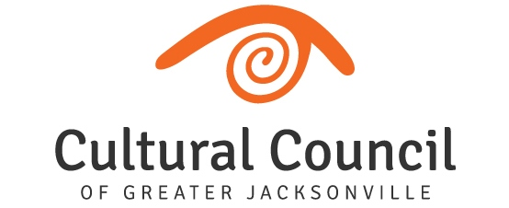
2021-2022 Cultural Service CAPITAL Grant Program Hearings
MINUTES (pending approval)
*10 a.m.-Conclusion; Thursday, June 23, 2022, in Room 208, 2nd Floor, Jessie Ball duPont Center
**REMOTE OPTION (FOR APPLICANTS ONLY):
https://us06web.zoom.us/j/86714533809 Meeting ID: 867 1453 3809 | Phone: +1 646 558 8656 US (New York)

CSGP Members Present In-Person: Wilton Blake, Jennifer Brown, Kirsten Doolittle, Alarie Gibbs, Kimberly Morrison, Sally Pettegrew, Karen Estella Smith, Tim Snyder, Angela Strain, Jeff Strohecker, Ellen Williams (Chair)
CSGP Members Absent: NA
Guests, including via Zoom: Chris Hoffman, Melanie Hammer & Kristin Livingston, Numa Saisselin & Michelle Adams, Jason Peoples & Tori Peoples, Bryan De Boer, Bruce Fafard, Julie Michael, Martha Lemire, Susana Cruz & Darren Dailey, Michelle Kindy, and Circe LeNoble, along with other secondary representatives from CSG applicants.
CCGJ Staff: Diana Donovan (Executive Director), Amy Palmer (Director of Grants Administration), John Poage (Grantmaking Manager), Sarah Chau (Contracted Consultant)
General Public: none attended
CALL TO ORDER: 10:01 AM
Introductions and Opening Remarks
Hearings for CAPITAL GRANT Applicants:
- Beaches Museum & History Park
- Cathedral Arts Project
- Florida Theatre
- Jacksonville Arts & Music School
- Jacksonville Symphony Association
- Museum of Science & History
- Players by the Sea
- The Florida Ballet
- The Jacksonville Children’s Chorus
- Theatre Jacksonville
- WJCT
Public Comment
Final Scoring and Funding Allocation Recommendations for Capital Grant Applicants
Certification of Scores for Capital Grant Applicants MOTION: Strain, 2nd: Doolittle.
Final Public Comment
Closing Remarks & Adjournment at 11:40 AM

