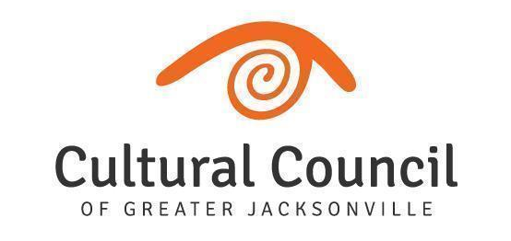
ART IN PUBLIC PLACES COMMITTEE
Meeting Minutes
Wednesday, November 9, 2022 1:00-2:30 PM
Jessie Ball duPont Center, 40 East Adams Street | Room 318 (Third Floor)
LINK: zoom.us/j/95032402968, Meeting ID: 50 3240 2968 | PHONE: +1 646 558 8656

Invitees: Cory Driscoll (Chair), Karen Feagins, David Faliszek, Elias Hionides, Gigi Ackerman, Kimberly Kim, Ylva Rouse, and Heather Terrill
Invited Guests: Michele Lee (Interim Director of Public Art), Kat Wright (Assistant Director), Iris Benson (Operations Coordinator), Iryna Kanishcheva (Contracted PM), Aisling Millar McDonald (Contracted PM), Jordan Stallings (Contracted PM); CCGJ Board and Staff; Noel Famy (Public Works); Reese Wilson (OGC)

IMPORTANT NOTE: An in-person quorum of 50% +1 is required to take any action on motions. The work of Art in Public Places for the City of Jacksonville requires motions be made in order for public art projects to move forward.

WELCOME Cory Driscoll

CALL TO ORDER & ATTENDANCE Cory Driscoll & Iris Benson

Called to order at 1:06 p.m. Quorum established

ACTION ITEMS - VOTING Cory Driscoll
- October 12, 2022 Art in Public Places Committee Meeting Minutes
Motion: The minutes of the October 12, 2022 meeting of the Art in Public Places Committee are approved as written. Karen Feagins moved to accept the minutes, Elias Hionides seconded the motion. The APPC unanimously approved the minutes for the October 12, 2022 meeting.

- Art in Public Places Committee Chair Discussion: Art in Public Places Committee Chair position
- Cory Driscoll discussed the opening of the Art in Public Places Committee (APPC) Chair position. The end of his term is December. He offered to the Committee what were the requirements for the position: run the meetings efficiently, and also be involved/engaged with the Art Selection Panels. Each APPC attending member was asked if they were interested in the Chair position. David Faliszek expressed interest but wanted to understand the meetings and time commitment. Gigi Ackerman also expressed interest.
- APP is presenting an approach to the councilmember Defoor next week, the meeting was postponed due to the upcoming hurricane.

DIRECTOR REPORT Michele Lee

NEW BUSINESS
- City Council District Enhancement Project for Public Art. Total Budget $639,115. CM DeFoor
Sponsored the initiative through the FY22-23 Budget Process.
- APP is presenting an approach to the councilmember Defoor next week, the meeting was postponed due to the upcoming hurricane

OLD BUSINESS
- Project Updates
Publicly-Funded Projects (APP Trust):
  - Courthouse Plaza Project Michele Lee
    - No update
    - Discussion around the foundational text
  - Mandarin Parks (2) Aisling Millar McDonald
    - Artist is working on the concepts and he's waiting on technical drawings of the park
  - Southside Senior Center Aisling Millar McDonald
    - Artist Meg White will be here December 6-7th

Publicly-Funded Projects (Other):
  - San Marco Intersection Painted Mural Kat Wright - December 7th and 8th
  - KingSoutel CRA Plan Iryna Kanishcheva
  - Don’t Miss A Beat Murals Iryna Kanishcheva
  - City Council Chambers Art on Loan Michele Lee

Privately-Funded Projects:
  - FIS Headquarters Michele Lee
  - Jacksonville Jaguars Miller Electric Center Project Michele Lee
    - Michele Leediscussed the CTA for the Jaguars project. A total of 163 total qualified responses.
    - Cory Driscollsuggested that the committee would like to be involved in seeing submissions for the Jaguars Project Management Team.
  - Johnson Brothers Sculpture at LEVS Park Michele Lee
    - The Jessie is privately funding this project
  - JTA Art on Loan ` Michele Lee

IMPORTANT DATES
- Next APPC Meeting: December 14, 2022, 1-2:30 PM, Jessie Ball duPont Center, Room 318 & Virtual

PUBLIC COMMENT - Public commenters must fill out and submit a green card prior to addressing the committee. Visitors will speak in the order cards are received. Public comments up to 3 minutes. Green cards must be submitted to Iris Benson directly if visiting in person. If visiting via Zoom, please email to Iris@culturalcouncil.org.

ADJOURNMENT

