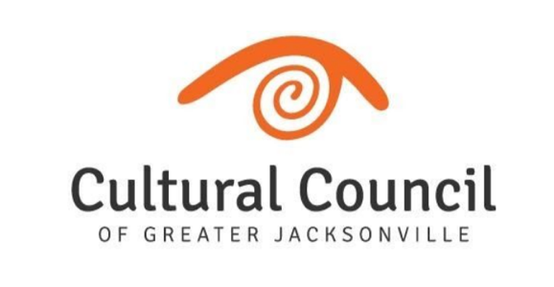
CULTURAL COUNCIL BOARD OF DIRECTORS
COMMUNICATION AND PUBLIC ENGAGEMENT REPORT
August, 2020

Every Single Artist Lounge
Every Single Artist Lounge had its first in-person event since the quarantine.
The event was at Don’t Miss a Beat and the speaker was Ulysses Owen, Jr, co-founder and artists director of DMAB. Ulysses is a Jacksonville native and one of the most sought-after drummers, educators, and thought leaders of his generation.
The topic of the mini-workshop portion of the event was:
Creative Entrepreneurism – Taking the show on the Road.
We have a t full three-hour workshop scheduled for September where Ulysses will continue the conversation about entrepreneurism.
Since the last report, we had the July virtual ESAL events which was a panel discussion made up of Jacksonville filmmakers. The event was streamed live on Facebook and had 1500 views and 950 engagements.
We have a complete calendar of locations and topics for the rest of 2020 and will be revised, as needed, depending on our ability to meet in person or not.
Arts Awards
The majority of my work in July and August has been focused on the Arts Awards. in addition to planning the award event, we have added some elements that will enhance the experience and keep the audience engaged, despite this being a virtual event. These will also serve as vehicles for fund raising, in lieu of ticket sales.
- Pre-awards virtual cocktail party
  - This is will be a zoom “party” that will start with a short cocktail making class of the signature arts awards cocktail. We will highlight auction items and have a drawing for a Caribbean vacation that was donated to the CC.
  - There is a $25 fee to enter the party.
- Online Auction
  - We will have an online auction that will run the week of the event. We are getting donations of retail certificates, trips, artwork and more.
- Text to give
  - Throughout the event we will have opportunities for those watching to donate directly on their phones.
- Entertainment
  - Violinist Philip Pan performing Bohemian Rhapsody
  - Students from Don’t Miss a Beat performing a self-written spoken-word piece.
Video promoting the arts in Jacksonville
As a response to the pandemic, we formed a Collective Messaging Committee to develop cohesive communications around donor support, staying engaged during lock-down, and safe reopening. Out of these meeting the idea was developed to create a video that is a montage of clips from a variety of our cultural organizations, with voice over messaging, welcoming people back and ensuring that they are taking every precaution for everyone’s safety.
The video is complete and we can view it now.
Public outreach via WJCT – First Coast Connect
We approached Melissa Ross about doing a segment that would highlight and bring awareness to the many unique arts and culture activities and events that are happening in the region. We feel it’s more important now than ever to bring the arts back into the minds of the community and let them know of all the wonderful, creative and SAFE things that are happening, all over town.

