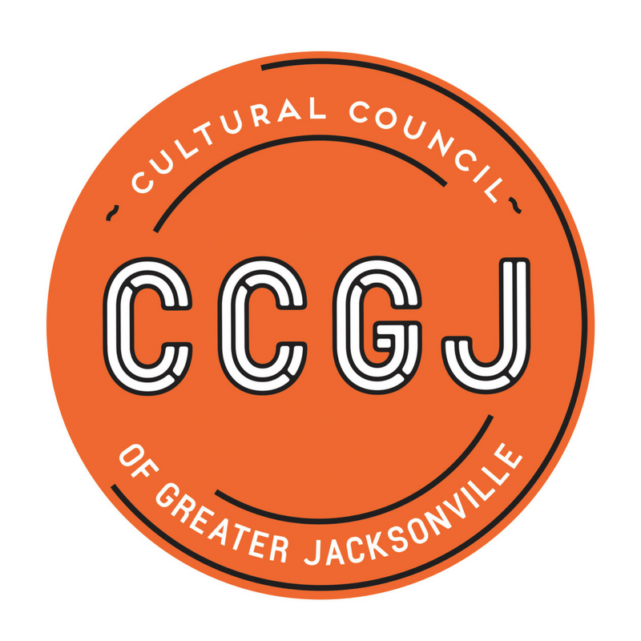
Enrich life in Northeast Florida by investing in Arts and Culture.

Board of Directors Meeting
August 16, 2018, 12:00 PM – 2:00 PM
Jacksonville City Hall
117 W Duval Street, Jacksonville, FL 32202
Don Davis Room

Pre-Reads (Available on Transparency webpage):
- Board of Directors Meeting Minutes, June 21, 2018
- Finance Committee Minutes, June 14, 2018
- July 2018 YTD Financial Statement (Blue Sheet)
- Governance Committee Minutes – July 12, 2018
- Art in Public Places - Committee Report, August 2018
- Cultural Service Grant Program – Committee Report, August 2018
- Executive Director’s Report, August 2018
- Succession Plan Highlights, August 2018
- Succession Plan – Draft, August 2018
- Executive Director Job Posting

Agenda:
- Call to Order - Ann Carey (5 min) 12:00-12:05
- Consent Agenda - Ann Carey (5 min) 12:05-12:10
  - Board Meeting Minutes – June 21, 2018
  - Finance Committee Minutes, June 14, 2018
  - Governance Committee Minutes, July 12, 2018
  - APP Committee Report, August 2018
  - CSG Committee Report, August 2018
  - Executive Director’s Report, August 2018
- Committee Reports
  - Finance - Board Donations Recommendation – Bill Ferry (5 min) 12:10-12:15
  - Governance Committee – Mac Bracewell (10 min) 12:15-12:25
- Executive Director Highlights – Tony Allegretti (15 min) 12:25-12:40
- Old Business
  - Executive Director Search – Ann Carey (25 min) 12:40-1:05
  - Development Committee – Kemal Gasper (10 min) 1:05-1:15
- New Business (20 min)
  - Economic Impact Study – Diana Donovan 1:15-1:25
  - Transfer of Programs: Internship and Lavilla Jazz Fest – Tony Allegretti 1:25-1:35
- Adjourn 1:45

*Items under the Consent Agenda are considered self-explanatory and are not expected to require review or discussion. Items will be enacted by one motion to approve. If discussion is desired by any Board member, that item will be removed from the Consent Agenda and considered separately.

