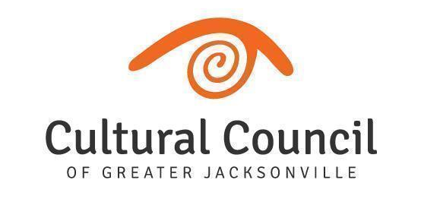
ART IN PUBLIC PLACES COMMITTEE
Meeting Agenda
Wednesday, December 14, 2022 1:00-2:30 PM
Jessie Ball duPont Center, 40 East Adams Street | Room 318 (Third Floor)
LINK: zoom.us/j/95032402968, Meeting ID: 50 3240 2968 | PHONE: +1 646 558 8656

Invitees: Cory Driscoll (Chair), Karen Feagins, David Faliszek, Elias Hionides, Heather Terrill, Gigi Ackerman, Kimberly Kim, Ana Kamiar, Ylva Rouse
Invited Guests: Michele Lee (Interim Director of Public Art), Kat Wright (Assistant Director), Iris Benson (Operations Coordinator), Iryna Kanishcheva (Contracted PM), Aisling Millar McDonald (Contracted PM), Jordan Stallings (Contracted PM); CCGJ Board and Staff; Noel Famy (Public Works); Joelle Dillard (OGC)

IMPORTANT NOTE: An in-person quorum of 50% +1 is required to take any action on motions. The work of Art in Public Places for the City of Jacksonville requires motions be made in order for public art projects to move forward.

WELCOME Cory Driscoll

CALL TO ORDER & ATTENDANCE Cory Driscoll & Iris Benson

ACTION ITEMS - VOTING Cory Driscoll
- November 9, 2022 Art in Public Places Committee Meeting Minutes
Motion: The minutes of the November 9, 2022 meeting of the Art in Public Places Committee are approved as written.

- Art in Public Places Committee Chair
Vote: David Faliszek and Gigi Ackerman - Chair and Co-Chair
Motion: The Art in Public Places Committee votes to appoint _______ to serve as Chair and Co-Chair of the Art in Public Places committee replacing Cory Driscoll.

DIRECTOR REPORT Michele Lee

NEW BUSINESS

OLD BUSINESS
- Project Updates
Publicly-Funded Projects (APP Trust):
  - Courthouse Plaza Project Michele Lee
  - Mandarin Parks (2) Aisling Millar McDonald
  - Southside Senior Center Aisling Millar McDonald

Publicly-Funded Projects (Other):
  - San Marco Intersection Painted Mural Kat Wright
  - KingSoutel CRA Plan Kat Wright
  - City Council Enhancement Project (4 Districts) Kat Wright
  - City Council Chambers Art on Loan Michele Lee

Privately-Funded Projects:
  - FIS Headquarters Michele Lee
  - Jacksonville Jaguars Miller Electric Center Project Michele Lee
  - Johnson Brothers Sculpture at LEVS Park Michele Lee

IMPORTANT DATES
- Next APPC Meeting: January 11, 2023, 1-2:30 PM, Jessie Ball duPont Cntr, Room 318 & Virtual

PUBLIC COMMENT - Public commenters must fill out and submit a green card prior to addressing the committee. Visitors will speak in the order cards are received. Public comments up to 3 minutes. Green cards must be submitted to Iris Benson directly if visiting in person. If visiting via Zoom, please email to Iris@culturalcouncil.org.

ADJOURNMENT

