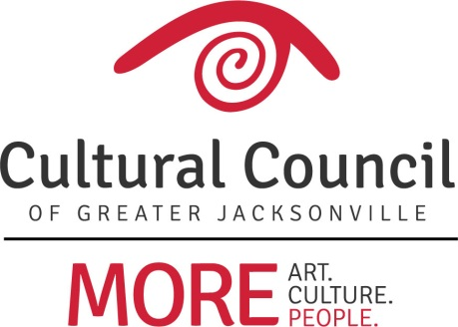

AGENDA - APPLICATION WORKSHOP – CSGP 2019-2020
Wednesday, April 17, 2019, 10 a.m.-noon @ WJCT

Welcome & Introductions

PART ONE

Housekeeping

Misc.

Process Changes for 2019-2020

Process Timeline

CSGP Committee

Foundant

PART TWO

Application

On-sites

Hearings

Questions?
- Read guidelines and instructions
- Website - check CSGP section of culturalcouncil.org for up-to-date information
- Contact staff
  - Amy Palmer (apalmer@culturalcouncil.org; (904) 358-3600 x14)
  - Chelsey Cain (chelsey@culturalcouncil.org; (904) 358-3600 x19)

