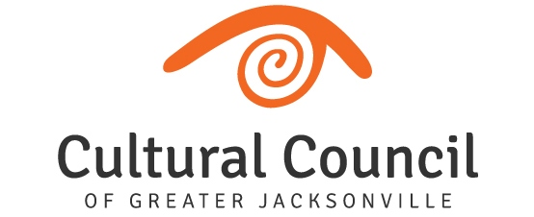
REVISED AGENDA (2)- FUNDING LEVEL TWO
2022-2023 Cultural Service Grant Program Hearings
Tuesday, Oct. 11, 2022
Room 208, 2nd Floor, Jessie Ball duPont Center
Committee and Staff Attending: Blake, Brown, Gibbs, Pettegrew, Snyder, Strain, Donovan, Palmer, Cruz, Wolfe, Poage, Benson
Organization Representatives Attending: Christy Ponder (Zoom), Kathy Wallis & Akia Uwanda McDaniel, Christine Hoffman, Gwen Owens & Ulysses Owens & Felicia Bass, Jason Peoples & Tori Peoples, Allan Bliss, Jereme Raickett & Ramona Ramdeen, Kelly Rich, Martha Lemire & Roberto Forleo, KT Boling (Zoom) & David DeCamps, Sarah Boone & Davarian Rousseau.

TUESDAY, OCT. 11 9:00 a.m. until conclusion
Introductions and Opening Remarks

Hearings for FUNDING LEVEL TWO Applicants:

- Art with a Heart in Healthcare
- (The) Jacksonville Children’s Chorus
- Theatre Jacksonville
- Springfield Preservation & Revitalization Council
- Players by the Sea
- Jacksonville Historical Society
- Jacksonville Arts & Music School
- (The) Florida Ballet
- Don’t Miss A Beat
- Beaches Museum and History Park
- Beaches Fine Arts Series

Final Scoring and Funding Allocation Recommendations for Funding Level Two Applicants

Certification of Scores for Level Two Applicants, to include audit language. Motion: Strain, 2nd Pettegrew.

Final Public Comment

Closing Remarks

Adjournment

