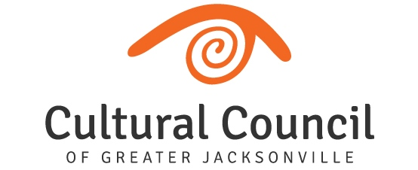
REVISED AGENDA (2)- FUNDING LEVEL THREE
2022-2023 Cultural Service Grant Program Hearings
Tuesday, Oct. 11, 2022
Room 208, 2nd Floor, Jessie Ball duPont Center
Committee and Staff Attending: Blake, Brown, Doolittle, Gibbs, Pettegrew, Snyder, Strain, Donovan, Palmer, Cruz, Wolfe, Poage, Benson
Organization Representatives Attending: Lee Hamby (Zoom), Jason Dearing & Rick Moran, Cindy Zarsky & Larry Arceneaux, Kurtis Loftus (Zoom), Steffani Fletcher, Jamie Rosseland, Katie McCaughan, Sandy Arpen, Terrance Patterson, Shannon Blankinship, Brad Akers, Ed Malesky & Lisa Loftus, Kathryn McAvoy & Ebony Payne-English.
TUESDAY, OCT. 11 Hearings commence following Level 2 conclusion
Introductions and Opening Remarks
LEVEL THREE – A (Currently-funded):
- Jacksonville Dance Theatre
- Ritz Chamber Players
- (The) Performer’s Academy
- Mandarin Museum and Historical Society
- Hope at Hand
- (The) 5 & Dime, A Theatre Company
- Deck the Chairs
- Civic Orchestra of Jacksonville
- Big Orange Chorus
- (The) Art Center Cooperative
- All Beaches Experimental Theatre
LEVEL THREE – B (New Applicant):
- Riverside Avondale Preservation

Final Scoring and Funding Allocation Recommendations for Funding Level Three Applicants

Certification of Scores for Level Three Applicants, to include audit language. Motion: Snyder, 2nd Doolittle.

Final Public Comment

Closing Remarks

Adjournment

