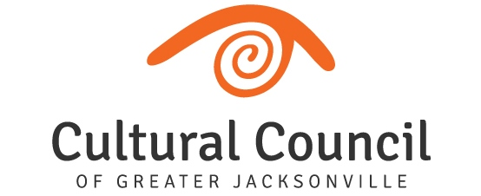
REVISED AGENDA (2)- FUNDING LEVEL ONE
2022-2023 Cultural Service Grant Program Hearings
Friday, Oct. 7, 2022
Room 208, 2nd Floor, Jessie Ball duPont Center
Committee and Staff Attending: Blake, Brown, Doolittle, Gibbs, Pettegrew, Smith, Snyder, Strain, Donovan, Palmer, Cruz, Lee, Poage, Benson
Organization Representatives Attending: Rev. Kimberly Hyatt & Charles Margiotta, Andrea Barnwell Brownlee & Pam Paul, Numa Saisselin & P.C. Bryant, Steven Libman & Don Baldwin, Caitlin Doherty& Anne Joseph, Bruce Fafard & William Magevney, David McGowan & Matthew Rapp, Darren Dailey.

FRIDAY, OCT. 7 1:30 p.m. until conclusion
Introductions and Opening Remarks

Hearings for FUNDING LEVEL ONE Applicants

- WJCT Public Broadcasting
- Museum of Science and History
- Museum of Contemporary Art - Jacksonville
- Jacksonville Symphony Association
- Florida Theatre
- Cummer Museum of Art and Garden
- Cathedral Arts Project

Final Scoring and Funding Allocation Recommendations for Funding Level One Applicants

Certification of Scores for Level One Applicants, to include audit language. Motion: Doolittle, 2nd Brown.

Final Public Comment

Closing Remarks

Adjournment

