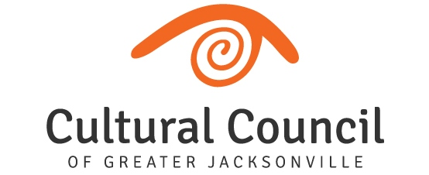

2020-2021 Cultural Service Grant Program

*(26) OPERATING Applicants:

FUNDING LEVEL ONE (8)
- Cathedral Arts Project
- Cummer Museum of Art and Garden
- Florida Theatre
- (The) Jacksonville Children’s Chorus
- Jacksonville Symphony Association
- Museum of Contemporary Art – Jacksonville
- Museum of Science and History
- WJCT Public Broadcasting
FUNDING LEVEL TWO (6)
- Beaches Museum and History Park
- (The) Florida Ballet
- Friday Musicale
- Jacksonville Historical Society
- Players by the Sea
- Theatre Jacksonville
FUNDING LEVEL THREE (12)
- (The) Art Center Cooperative
- All Beaches Experimental Theatre
- Beaches Fine Arts Series
- Civic Orchestra of Jacksonville
- Don’t Miss A Beat
- Hope at Hand
- Jacksonville Arts & Music School
- Jacksonville Dance Theatre
- Mandarin Museum and Historical Society
- (The) Performer’s Academy
- Ritz Chamber Players
- Springfield Preservation & Revitalization Council

*Changes in funding levels may be identified following submission of applications

(4) PROGRAM Applicants:

- Big Orange Chorus
- Memorial Park Association
- Northeast Florida Art Education Association
- The 5 & Dime, A Theatre Company

