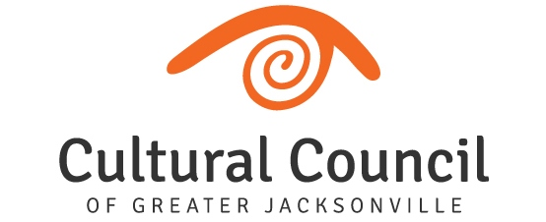

2020-2021 Cultural Service Grant Program
(36) ELIGIBLE APPLICANTS

*(25) Returning Cultural Service Grantees:

FUNDING LEVEL ONE (8)
- Cathedral Arts Project
- Cummer Museum of Art and Garden
- Florida Theatre
- (The) Jacksonville Children’s Chorus
- Jacksonville Symphony Association
- Museum of Contemporary Art – Jacksonville
- Museum of Science and History
- WJCT Public Broadcasting
FUNDING LEVEL TWO (7)
- Beaches Museum and History Park
- (The) Florida Ballet
- Friday Musicale
- Jacksonville Historical Society
- Players by the Sea
- Ritz Chamber Players
- Theatre Jacksonville
FUNDING LEVEL THREE (10)
- (The) Art Center Cooperative
- All Beaches Experimental Theatre
- Beaches Fine Arts Series
- Civic Orchestra of Jacksonville
- Don’t Miss A Beat
- Hope at Hand
- Jacksonville Dance Theatre
- Mandarin Museum and Historical Society
- (The) Performer’s Academy
- Springfield Preservation & Revitalization Council

*Changes in funding levels may be identified following submission of applications

(6) Returning Program Grantees (eligible for operating or program grant):
- Avant
- Jacksonville Arts and Music School
- Riverside Avondale Preservation
- San Marco Chamber Music Society
- Stage Aurora Theatrical Company
- The 5 & Dime, A Theatre Company

(5) New organizations – submitted eligible Letters of Intent (eligible for program grant):

- Big Orange Chorus
- Kim’s Open Door
- Memorial Park Association
- Northeast Florida Art Education Association
- Sleeping Giant Fest

