2020-2021 CULTURAL SERVICE GRANT PROGRAM COMMITTEE

CHAIR - Kenyon Varn Merritt

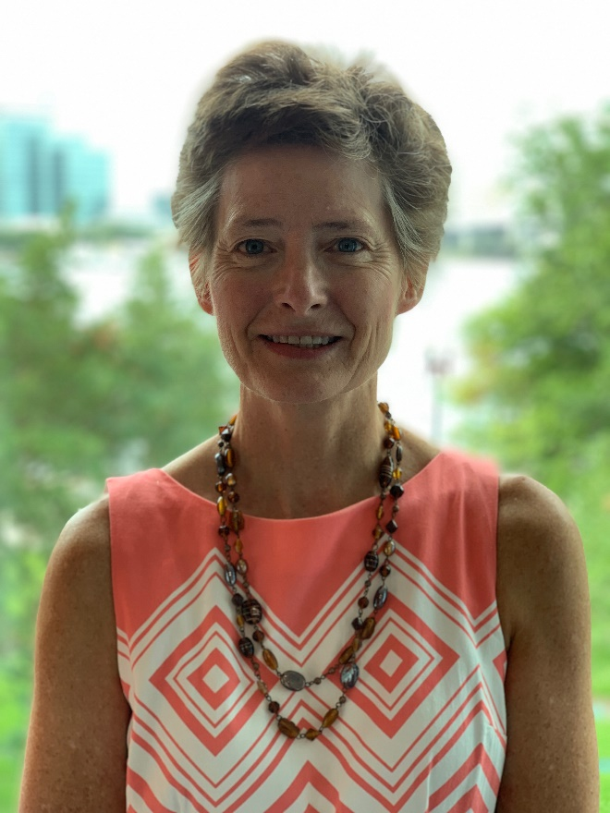

- Served as a CSGP Committee member from 2014-2016
- Second year as Chair
- Community Representative
- Native of Jacksonville
- Work and/or volunteer experience - areas of interest in non-profit sector:
  - development and governance – has worked both professionally and as a volunteer in
development for the past 35 years.
  - Community Service- Currently serving on RiverKeeper board and Memorial Park Association Board Affairs committee.
  - Past boards: Jacksonville Zoo and Gardens,Cummer Museum of Art &Gardens, Leadership Jacksonville, Junior League of Jacksonville
- Education: Hollins University, BA English/Psychology

*Diana Donovan – Board Representative

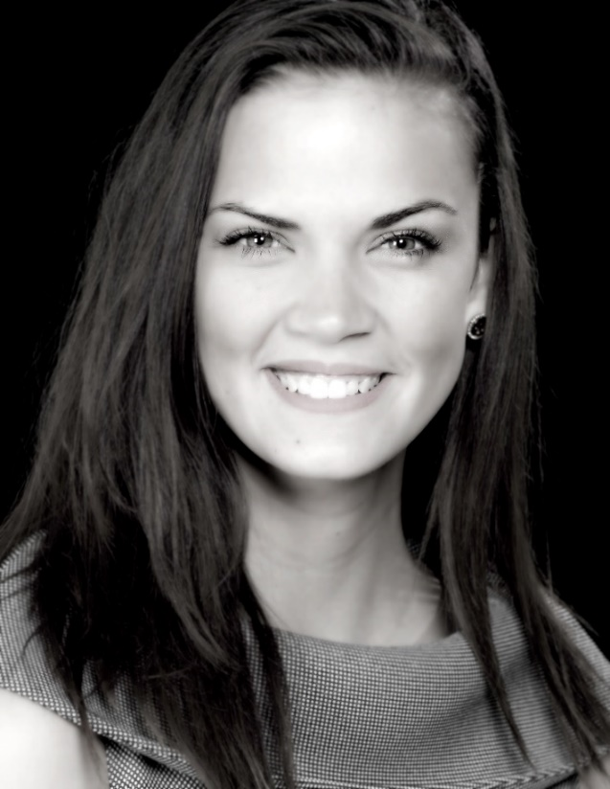
- Second year on the CSGP Committee
- Board Member
- Originally from Philadelphia
- Recently awarded Jacksonville Business Journal’s 40 under 40 and recently accepted into Leadership Jacksonville’s Class of 2021
- Experienced Director with a demonstrated history of working in the higher education industry. Skilled in Administration, Project Management, Relationship Development, High Level Event Planning & Implementation, Public Speaking, Philanthropy, Process Designer, and Organizational Development. Strong and consistent leadership abilities, effective communicator, as well as a champion for innovative and collaborative strategies and programs.
- Education:
  - Jacksonville University, Bachelor of Science, Psychology
  - Jacksonville University, Master’s in Public Policy, Expected 2021
- Loves running and completed first half marathon and 15K this year. Enjoys gluten free pasta and the occasional walk on the beach. Diana is also a former singer and published poet.

*Diana resigned her positions on the Cultural Council Board of Directors and CSGP Committee effective Sept. 11, 2020, and is now serving as the Interim Director for the Cultural Council. Her on-site visits and evaluation reports were conducted and submitted while still a member of the committee; however, her scores will not be included due to these resignations.
David Faliszek – Board Representative
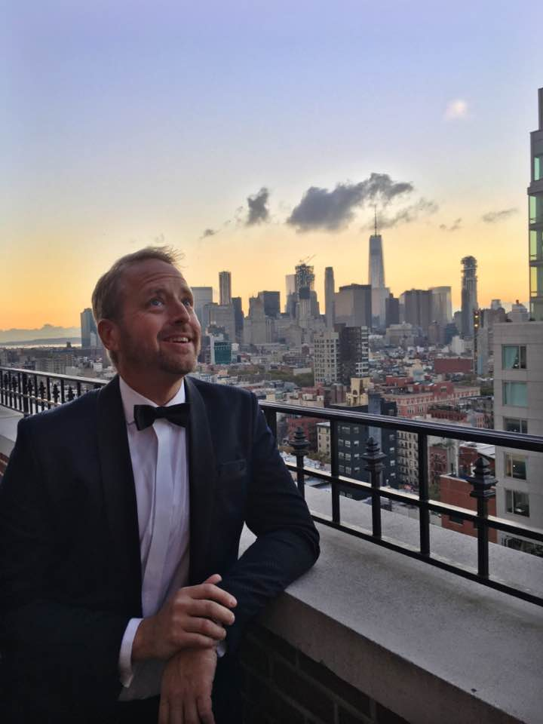

- Third Year on the CSGP Committee
- Board Member
- National Contracts and Lender Strategy Counsel at Fidelity National Financial
David enjoys visiting arts organizations throughout Jacksonville. He enjoys seeing the new and exciting things that artists are doing, and even took a beginner’s glassblowing class at Jacksonville University in the spring of 2020.
- He attended the University of Notre Dame for his undergraduate degree and the University of Southern California for his Doctor of Law.

Sandra Hull-Richardson – Board Representative

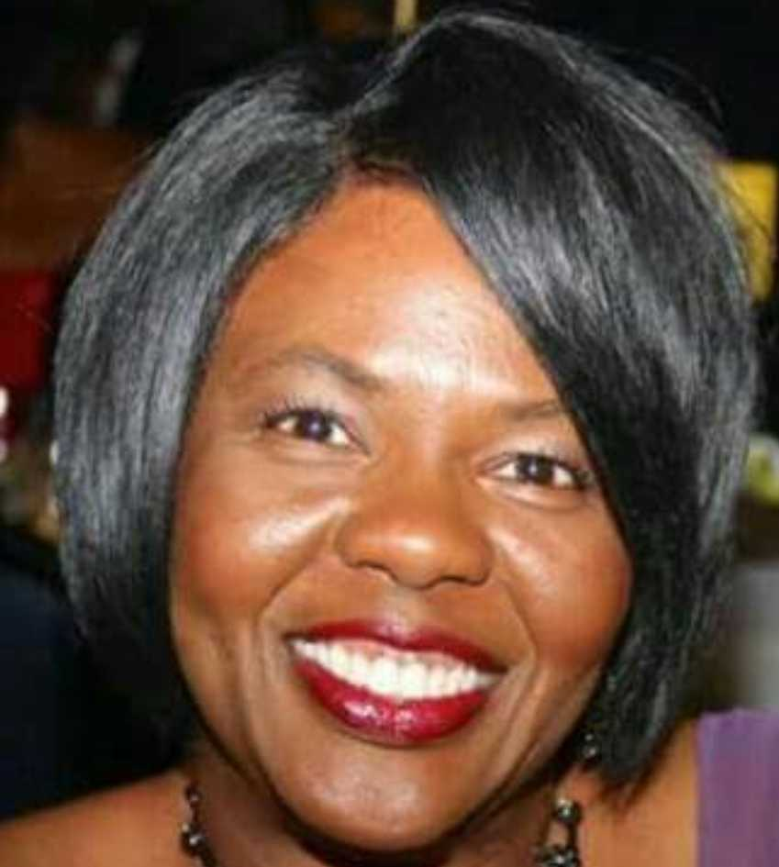

- Fourth year on the committee
- Board Member
- Sandra Hull-Richardson is a retired Division Chief with the City of Jacksonville
- Born in Atlanta, Sandra was reared in Jacksonville.
- She is a graduate of the University of Florida.
- She has been married to James A. Richardson, II for 30 years.

Truitte Moreland – Community Representative
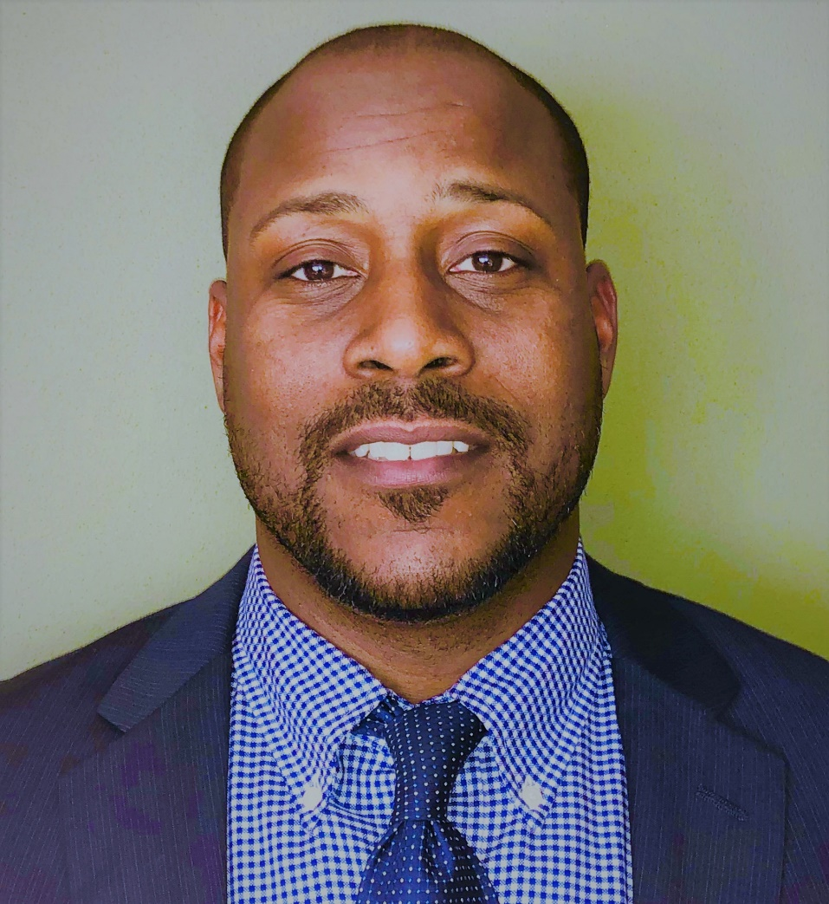
- Third year on the committee
- Community Representative
- Originally from South Florida
- He has worked in education in public school settings or non-profit organizations for the last 20 years.
- He has been a School Principal for seven years.
- He serves as a youth soccer coach in the Oceanway area of Jacksonville.
- He was the Gold Medallion recipient for the 2017 Leonard Miller Principal Leadership Award from the Council for Educational Change.
- He was also a recipient of the Innovation in Education Award from the Jacksonville Business Journal.

- Sally Pettegrew – Community Representative
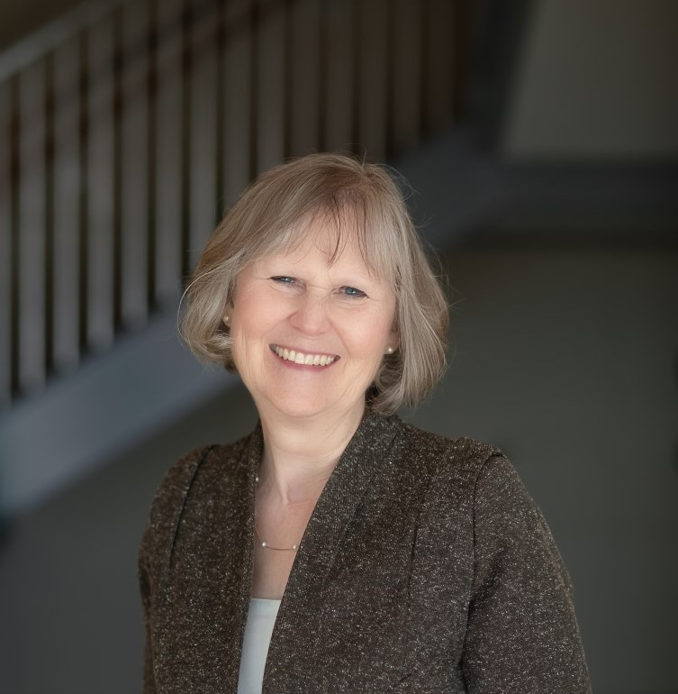
- First year on committee
- Community Representative
- She is a native of Maryland and has lived in Jacksonville for over 35 years.
- Sally was on the administrative staff of the Jacksonville Symphony for 35 years and is currently on the staff of the Community Foundation for Northeast Florida.
- She has a BA in History and a MA in Speech &Drama (emphasis in Costume Design) and has designed costumes for local theatre productions since moving to Jacksonville in 1983.
- Her husband Johnny is a scenic designer and established the Entertainment Technologies program at FSCJ—South Campus.
- They have three children: Dustin (a freelance scenic designer in Philadelphia and adjunct instructor at Temple University), Janna (an interior design consultant with ICI Builders in Daytona), and Brandon (a Global Wealth Investment Management Registered Operations Team Manager at Merrill).

Ben Rubin – Community Representative

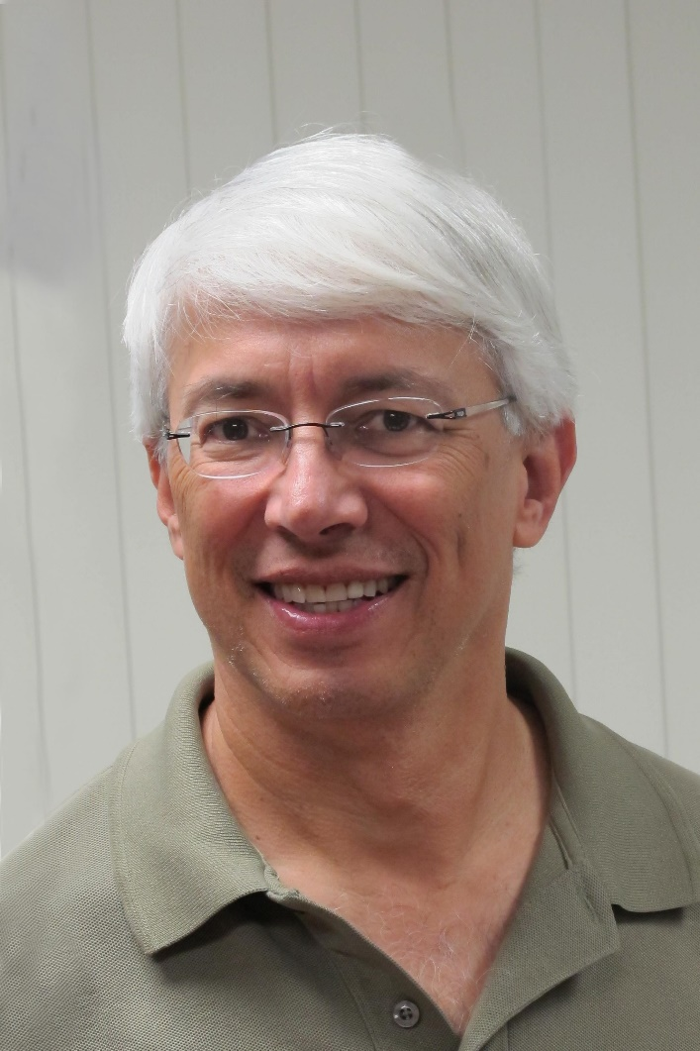

- Three years on CSGP Committee
- Community Representative
- Background Info:
- Ben is an Engineering Manager at Medtronic involved in the development of surgical products. He’s lived in Jacksonville for over 30 years.
- Two of his three children attended Douglas Anderson School of the Arts. One is a professional Artist who has created two permanent sculptures located in Jacksonville.
- Ben plays Tenor Sax in the Jacksonville Community Band and has recently learned the sport of Curling.

Karen Estella Smith – Community Representative

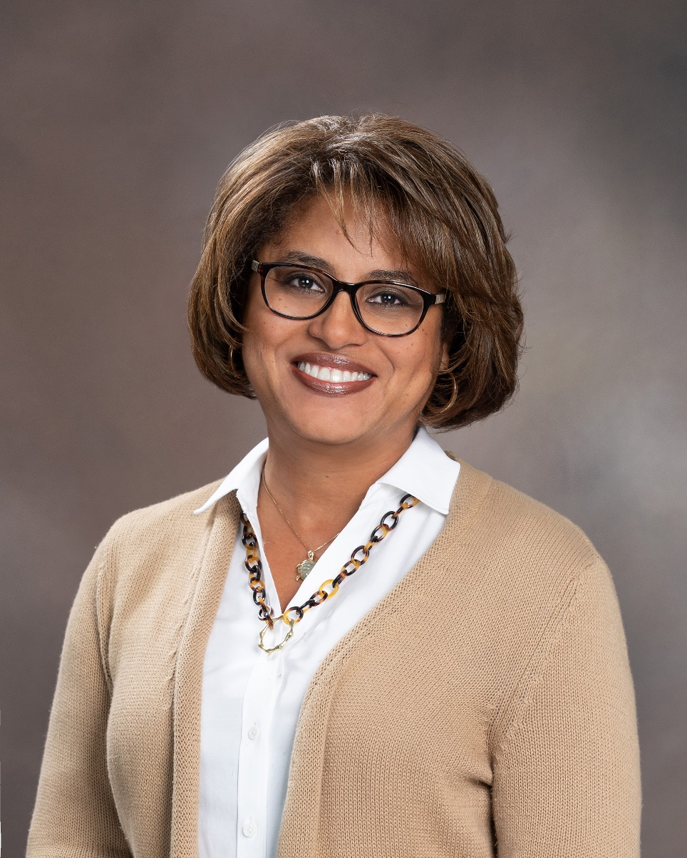
- First Year on the CSGP Committee
- Community Representative
- Originally from Jacksonville
- Karen says: I fell in love with Arts & Culture in my 11th grade Humanities class; and, still have fond memories of the lessons learned about artists and periods in history that influenced, captured, and defined eras, trends, and culture.
- Currently work for Volunteers in Medicine, Jacksonville in Development
- Board of Director for Jacksonville Zoo & Gardens; Board of Trustees, Episcopal Children’s Services
- Graduate of the Florida State University with a degree in English Literature and currently in graduate studies for a Masters in Biology from Miami University (OH), focusing on Conservation, Environmental Stewardship, and Environmental Justice

Angela Strain – Community Representative
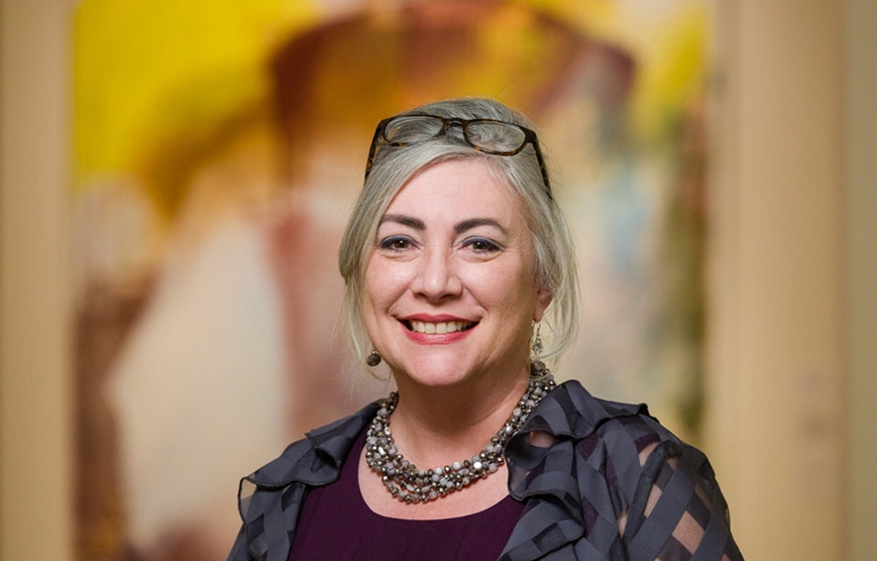
- First year on committee
- Community Representative
- Angela Strain, GPC, WeCareJax Executive Director, brings over 20 years of experience in Nonprofit management to her role.
- She previously served as inaugural Director of Development for JASMYN, Inc., where she drafted and implemented the organization’s first strategic three-year fund development plan.
- Locally, she also worked with the team at MOCA Jacksonville in helping secure support for their programs and collections.
- She attended the University of Memphis, where she earned her BA with a major in Public Administration and minor in English.
- She was a long-time consultant for the Alliance for Nonprofit Excellence.
- Angela graduated in the 2018 class of Leadership Jacksonville and maintains certification through the Grant Professionals Credentialing Institute (GPC).
- She served as president of North Florida Grant Professionals, a chapter of the National Grant Professionals Association, and she is a volunteer Community Coach with the Nonprofit Center of Jacksonville.
- Today, she is responsible for ensuring that uninsured neighbors referred for specialty healthcare are provided with the highest quality services available through the WeCareJax volunteer network of over 520 physicians and the major hospital systems in Duval County.
- She and her wife of nineteen years believe in the power of art to heal, to inspire, and to inform.

Kedgar Volta – Community Representative
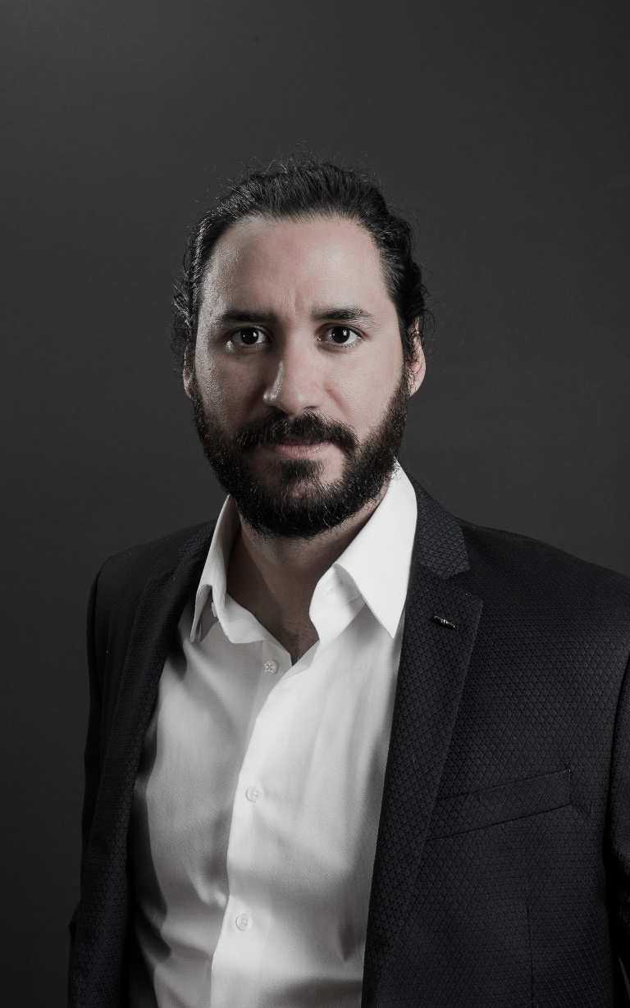
- First year on the committee
- Community Representative
- Kedgar Volta has been a part of the Jacksonville arts and creative community for over a decade.
- As co-founder and Creative Director of Castaño Group, he has used interactive technology and his talent for design to create innovative new ways to communicate in digital and physical environments.
- After emigrating to Florida from Cuba, Kedgar began his career at Brunet-García Advertising where he created internationally recognized work running the gamut from typography to animation.
- He's been a featured artist at Art Basel Miami Beach and the Crystal Bridges Museum of American Art and has been awarded multiple National ADDY and Emmy Awards.
- In 2015, he was named Emerging Artist of the Year by the Cultural Council of Greater Jacksonville.

Ellen Williams – Community Representative

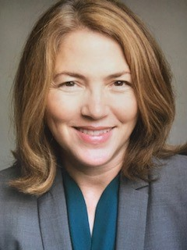

- Second year on committee
- Community Representative
- Ellen A. Williams, PhD, is a clinical psychologist with over 20 years of leadership experience in healthcare.
- She is the Regional Director for Behavioral Health at Ascension St. Vincent’s in Jacksonville, Florida.
- Ellen has focused on improving access to mental health care in NEFL for over a decade by recruiting mental health practitioners to the area and integrating mental health providers into primary and specialty care practices.
- She has worked tirelessly to reduce the stigma that surrounds mental illness and has spearheaded prevention initiatives such as Mental Health First Aid and Mindfulness Meditation training.
- She serves on the American Hospital Association Psychiatric and Substance Abuse Council and was a 2020 Women With Heart Honoree with Volunteers in Medicine.
- Her interests include music, art, travel, and the great outdoors.

The Honorable Michael Boylan – Jacksonville City Council Liaison

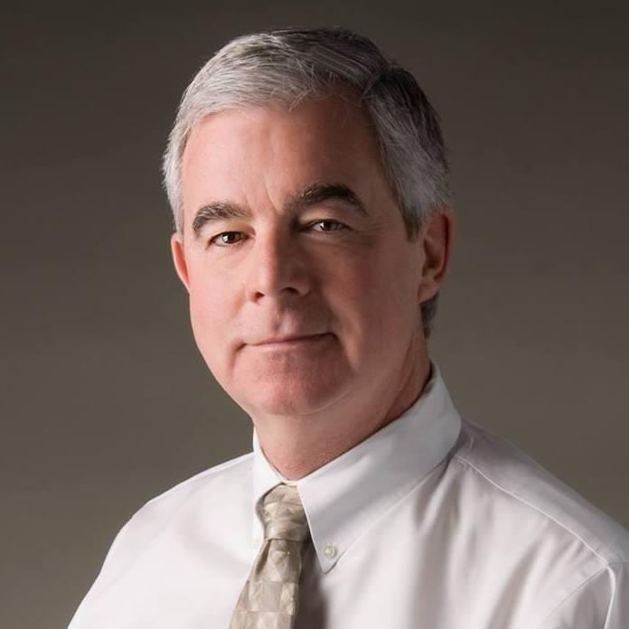
The Honorable Michael Boylan is a member of the Jacksonville City Council, serving District. He serves as the City Council liaison to the Cultural Council of Greater Jacksonville.

Michael Boylan and his family moved to Jacksonville in May, 1999 when he joined WJCT Public Broadcasting as its President &CEO. During his tenure WJCT completed the federally mandated transition to digital television in 2003, not only broadcasting in high definition but increasing its number of television channels from one to five, the last of which was the 24-hour PBS Kids Channel. In 2006 WJCT introduced the first full-powered HD radio station on the First Coast and added two more HD radio services…89.9HD Arts and Relax Radio. Under his leadership WJCT forged numerous community partnerships and the development of a wealth of local programs and outreach initiatives.

In 2013 Michael took the lead in forging the Digital Convergence Alliance, eleven public television stations from around the country with the goal of developing initiatives that would result in significant operational savings and the generation of new revenue opportunities for its members. The first venture was the creation a broadcast operations service, managed and operated by WJCT’s affiliate, JCT Services, that provides more than 17 million households with public television, all emanating from Jacksonville.

His personal commitment of service spans the 20 years he has called Jacksonville home. He has held board leadership roles on a broad array of community organizations including Leadership Jacksonville, the North Florida Council of the Boys Scouts of America, the Jacksonville Symphony Association, Visit Jacksonville and St. Vincent’s Healthcare, to name just a few. He currently serves as the Chair of the Northeast Florida Long Term Recovery Organization (NFLTRO) leading more than 30 faith-based, non-profit, governmental agencies and businesses working together to assist families in the repair and/or replacement of their homes which were damaged during Hurricane Irma. Through the NFLTRO, the occurrence of duplicated services is reduced and the efforts of all involved agencies are amplified and leveraged so as to effectively and expediently serve these individuals and families. He is also the current Chair of the Board for Volunteers in Medicine which offers free healthcare services to the working uninsured.

Michael is a graduate of John Carroll University and received his Master’s degree in Telecommunications from Kent State University. He and his wife, Susan, have been married for 42 years; have two grown children, one grandson and one granddaughter. They have called Mandarin home since arriving here in 1999 and are members of San Juan Del Rio Catholic Church where he has served as chair of its last two building campaigns.

