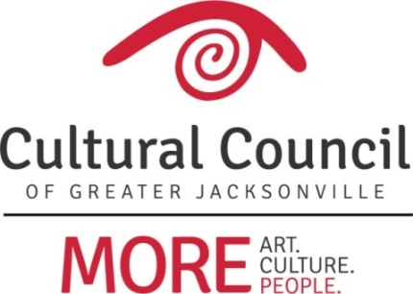

2018-2019 Cultural Service Grant Program On-site Assignments

FUNDING LEVEL ONE
- Cathedral Arts Project Mac Bracewell
- Cummer Museum of Art & Gardens Mauricio Gonzalez
- Florida Theatre Ben Rubin
- Jacksonville Symphony Association Sandra Hull-Richardson
- Museum of Contemporary Art - Jacksonville Richard Naylor
- Museum of Science & History Truitte Moreland
- WJCT Public Broadcasting Anne Boccuzzi
FUNDING LEVEL TWO
- **Beaches Fine Arts Series Mauricio Gonzalez
- Beaches Museum & History Park David Faliszek
- (The) Florida Ballet Sandra Hull-Richardson
- Friday Musicale David Faliszek
- (The) Jacksonville Children’s Chorus Jannet Walker Ford
- Jacksonville Historical Society Jannet Walker Ford
- Players by the Sea Anne Boccuzzi
- Ritz Chamber Players Richard Naylor
- Theatre Jacksonville David Faliszek
- Theatreworks Anne Lufrano
FUNDING LEVEL THREE
- *(The) Art Center Cooperative Mauricio Gonzalez
- Atlantic Beach Experimental Theatre Ben Rubin
- Civic Orchestra of Jacksonville Mac Bracewell
- Don’t Miss A Beat Truitte Moreland
- Hope at Hand Anne Lufrano
- Jacksonville Dance Theatre Ben Rubin
- Mandarin Museum & Historical Society Richard Naylor
- Riverside Fine Arts Association Anne Boccuzzi
- Springfield Preservation & Revitalization Council Mac Bracewell
- (The) Performer’s Academy Sandra Hull-Richardson

*New applicant
**Change in Level

2018-2019 Cultural Service Grant Program On-site Assignments

Anne Boccuzzi
Players by the Sea
Riverside Fine Arts Association
WJCT Public Broadcasting

Mac Bracewell
Cathedral Arts Project
Civic Orchestra of Jacksonville
Springfield Preservation & Revitalization Council

David Faliszek
Beaches Museum & History Park
Friday Musicale
Theatre Jacksonville

Mauricio Gonzalez
(The) Art Center Cooperative
Beaches Fine Arts Series
Cummer Museum of Art & Gardens

Sandra Hull-Richardson
(The) Florida Ballet
Jacksonville Symphony Association
(The) Performer’s Academy

Anne Lufrano
Hope at Hand
Theatreworks

Truitte Moreland
Don’t Miss A Beat
Museum of Science & History

Richard Naylor
Mandarin Museum & Historical Society
Museum of Contemporary Art - Jacksonville
Ritz Chamber Players

Ben Rubin
Atlantic Beach Experimental Theatre
Florida Theatre
Jacksonville Dance Theatre

Jannet Walker Ford
(The) Jacksonville Children’s Chorus
Jacksonville Historical Society

