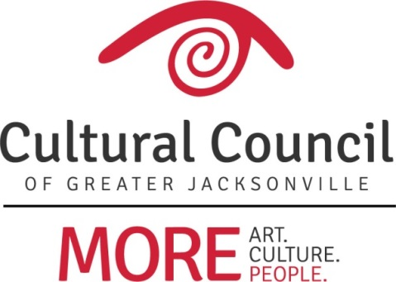

2017-2018 Cultural Service Grant Program On-site Assignments*

FUNDING LEVEL I
- Cathedral Arts Project Richard Naylor
- Cummer Museum of Art & Gardens Ann Carey
- Florida Theatre Mac Bracewell
- Jacksonville Symphony Association Beth Harvey
- Museum of Contemporary Art – Jacksonville Frank Watson
- Museum of Science & History Anne Boccuzzi
- WJCT Public Broadcasting Sandra Hull-Richardson
FUNDING LEVEL II
- Beaches Museum & History Park Ben Rubin
- Florida Ballet Richard Naylor
- Friday Musicale Richard Naylor
- Jacksonville Children’s Chorus Mauricio Gonzalez
- Jacksonville Historical Society Frank Watson
- Players by the Sea Ann Carey
- Ritz Chamber Players Beth Harvey
- Theatre Jacksonville Sandra Hull-Richardson
- Theatreworks Truitte Moreland
FUNDING LEVEL III
- Atlantic Beach Experimental Theatre Mauricio Gonzalez
- Beaches Fine Arts Series Ben Rubin
- Civic Orchestra of Jacksonville Ann Carey
- Don’t Miss A Beat Beth Harvey
- Hope at Hand Sandra Hull-Richardson
- Jacksonville Dance Theatre Mauricio Gonzalez
- Mandarin Museum & Historical Society Anne Boccuzzi
- Riverside Fine Arts Association Mac Bracewell
- Springfield Preservation & Revitalization Council Ben Rubin
- The Performer’s Academy Truitte Moreland

*New applicant

2017-2018 Cultural Service Grant Program On-site Assignments

Anne Boccuzzi
Mandarin Museum & Historical Society
Museum of Science & History

Mac Bracewell
Florida Theatre
Riverside Fine Arts Association

Ann Carey
Civic Orchestra of Jacksonville
Cummer Museum of Art & Gardens
Players by the Sea

Mauricio Gonzalez
Atlantic Beach Experimental Theatre
Jacksonville Children’s Chorus
Jacksonville Dance Theatre

Beth Harvey
Don’t Miss A Beat
Jacksonville Symphony Association
Ritz Chamber Players

Sandra Hull-Richardson
Hope at Hand
Theatre Jacksonville
WJCT Public Broadcasting

Truitte Moreland
Theatreworks
The Performer’s Academy

Richard Naylor
Cathedral Arts Project
Florida Ballet
Friday Musicale

Ben Rubin
Beaches Fine Art Series
Beaches Museum & History Park
Springfield Preservation & Revitalization Council

Frank Watson
Jacksonville Historical Society
Museum of Contemporary Art - Jacksonville

