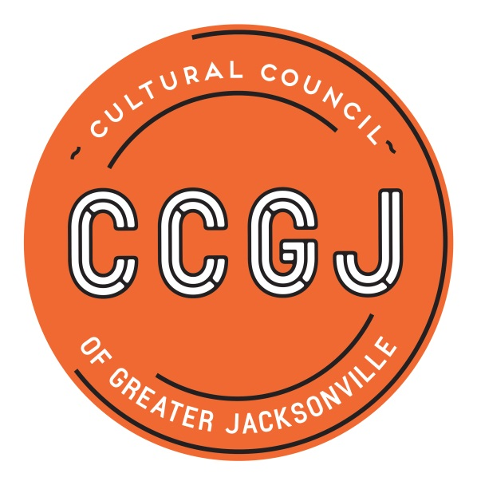

2019-2020 Cultural Service Grant Program – CSGP Process Timeline for Organizations

EVENT | DEADLINES & DATES | TIME | LOCATION
Letter of Intent | Tuesday, March 5, 2019 | 11:59 p.m. | Online
Cultural Equity Commitment one-on-one meetings with CCGJ E.D. | March/April 2019 | TBD | Cultural Council  300 Water St., Ste. 201, Jax 32202
Eligibility Notification | April 2019 | N/A | N/A
Application Workshop | Wednesday, April 17, 2019 | 10 a.m.-noon | WJCT  100 Festival Park Ave.  Jax 32202
Full Application | Tuesday, June 18, 2019 | 11:59 p.m. | Online
On-site Visit from member of CSGP Committee | July/August 2019 - applicant to schedule with assigned reviewer | TBD - applicant to schedule with assigned reviewer | At applicant’s facility/office
Jax City Council Votes to Approve City Budget (includes CSGP allocation) | Tuesday, Sept. 24, 2019 | 5 p.m. | City Council Chamber, City Hall, 117 W. Duval St., Jax 32202
Hearings | Wednesday, Sept. 25 (LEVEL THREE) & Thursday, Sept. 26, 2019 (LEVELS ONE & TWO) | 9 a.m.-5 p.m. | Davis Gallery, Times-Union Center for the Performing Arts (TUCPA)  300 Water St.  Jax 32202
Cultural Council Board of Directors meeting -  approval of CSGP awards | Thursday, Oct. 17, 2019 | Noon-2 p.m. | Lynwood Roberts Room, Jacksonville City Hall,  117 W. Duval St.  Jax 32202
Grant Process Survey | October/November 2019 | N/A | Online
CSGP Appreciation Mixer | Thursday, Dec. 5, 2019 | 4:30-6 p.m. | Cultural Council
Grantee Compliance Workshop | Wednesday, Dec. 11, 2019 | 10 a.m. - noon | WJCT
Grant Period | Oct. 1, 2019-Sept. 30, 2020 | N/A | N/A

