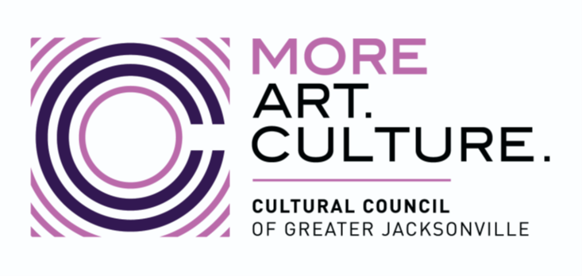

PUBLICITY RELEASE

I hereby grant the Cultural Council of Greater Jacksonville, Inc. and PNC/PNC Foundation to use any comments, endorsements, quotes, and/or my likeness in a photograph, video, or other digital media (“photo”) in any and all of its publications, including web-based publications, without payment or other consideration.
I understand and agree that all such photos will become the property of the aforementioned organizations and will not be returned.
I hereby irrevocably authorize the aforementioned organizations to edit, alter, copy, exhibit, publish, or distribute these photos for any lawful purpose. In addition, I waive any right to inspect or approve the finished product wherein my likeness appears. Additionally, I waive any right to royalties or other compensation arising or related to the use of the photo.
I hereby hold harmless, release, and forever discharge the aforementioned organizations from all claims, demands, and causes of action which I, my heirs, representatives, executors, administrators, or any other persons acting on my behalf or on behalf of my estate have or may have by reason of this authorization.

I have read, understand, and accept the above release.

Name: _______________________________________

Date: ________________________________________

Signature: _____________________________________

