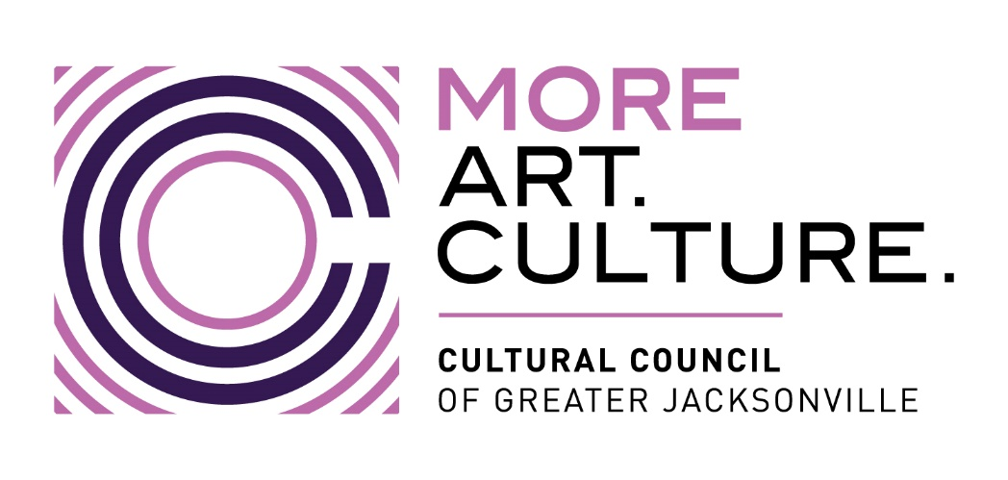

MINUTES
Cultural Council of Greater Jacksonville
Governance Committee Meeting
Monday, June 12, 2023; 3 p.m.
Location: The Jessie, Room 202

Present:
Members - Chair Lisa Johnson, David Faliszek, Karen Feagins, Ari Jolly
Staff – Diana Donovan, Amy Palmer

- The meeting was called to order at 3:14 p.m. by the chair, Lisa Johnson.

- A discussion of the current draft of the updated bylaws was led by Director Johnson.

  - Discussion points included:
    - Suggested revisions thus far
    - Changes should reflect new strategic plan
    - Definition of a quorum constituting a majority of the members
    - Indemnification inclusion
    - Ethics code inclusion using DVI and Visit Jax as models
    - Using a template for the bylaws

- The timeline for board approval of the amended bylaws was discussed, along with next steps. These include:
  - (Staff) consulting with the Cultural Council attorney on the removal or strike-through of the bylaws sections on membership, with respect to the articles of incorporation.
  - Preparing a final redline for Governance Committee review at its August meeting. This final draft will then be provided to the board for input through a survey following the August board meeting. It is anticipated that the board will approve the amended bylaws at its October meeting. The Governance Committee will have the opportunity to review the final draft, which would include any additional board input, at its Oct. meeting.

- New and Old Business included:
  - Suggestion of creating charters for each board committee that include expectations for both mayoral and elected board members.
  - Suggestion to have a reimbursement fund for cultural visits to CSGs by board members
  - Discussion of what is involved in ordinance change.

- There was no public comment.

- The meeting was adjourned at 4:50 p.m.

