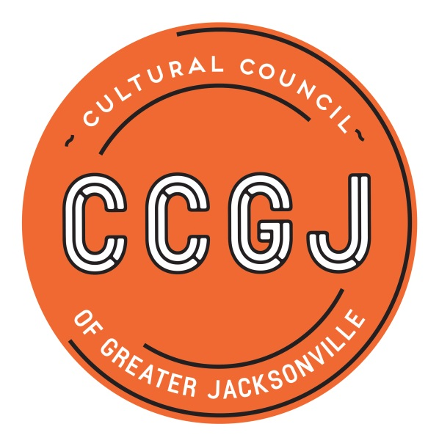

CSGP Pre-read for January 17, 2019 CCGJ BOD Meeting

2019-2020 CSGP LOI
The application process for the Cultural Service Grant Program (CSGP) begins with a Letter of Intent to Apply, or LOI. For organizations not currently funded through CSGP, completing the Letter of Intent (LOI) is a mandatory prerequisite to completing the full application for the 2019-2020 Cultural Service Grant Program. Currently-funded organizations must complete an abbreviated version of the LOI to ensure that they have maintained eligibility for CSGP for 2019-2020.

The purpose of the LOI is to:
- Signal the organization's intention to apply to CSGP
- Determine eligibility for applicant organizations
- Gather essential information and documentation
- Inform the Cultural Council of Greater Jacksonville's request for funding to the City of Jacksonville for the Cultural Service Grant Program.

The deadline for the LOI for the 2019-2020 CSGP process will be Tuesday, March 5, 2019. The online LOI form will be available through the Cultural Council’s website and promoted through a press release, public notice, the Cultural Council’s e-newsletter, and targeted emails to current grantees and prospective applicants.

