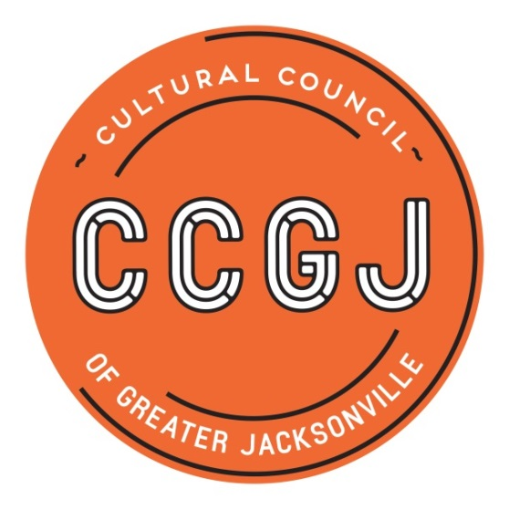

Cultural Service Grant Program (CSGP)
CSGP Committee Member - Volunteer Description

Description | - The Cultural Service Grant Program (CSGP) provides general operating support to Duval County arts and cultural organizations that positively impact quality of life. CSGP is funded by the City of Jacksonville and administered by the Cultural Council of Greater Jacksonville, Inc.  - Recommendations for Cultural Service Grant awards to applicant organizations are made by the CSGP Committee to the Cultural Council Board of Directors, which makes the final determination of funding.  - The CSGP Committee is comprised of a cross-section of members from Jacksonville’s diverse communities representing racial/ethnic, gender, geographic and age diversity.  - Committee members, who are confirmed by the Jacksonville City Council, include a chairperson, three Cultural Council board members, seven community members, and ex-officio liaisons from the Mayor’s Office, City Council and the Cultural Council’s board.
Panelist Requirements | - Reside in Duval County  - Express an interest in the impact of art and culture in the community  - Willing to participate fully in the CSGP process  - Have access to, and be able to use, a computer to review grant applications through Internet-based system  - Agree to abide by Sunshine, Public Records and Ethics laws
Term of Service | - One three-year term  - Renewable for an additional three-year term  - (Service occasionally includes completing a resigning committee member’s unexpired term)
Time Commitment | - One City Ethics Training workshop  - Approximately four committee meetings (average: two hours each) as well as additional ad hoc trainings/meetings  - Public grant hearings (three funding levels; two full days)  - Reviewing and scoring applications (average: 25 applications)  - Conducting on-site visits of assigned applicants and writing on-site evaluation reports (average: two-three on-sites)  - Making program visits of CSG-funded organizations throughout the year
Key Responsibilities & Expectations | - Attend all committee meetings  - Attend and participate in public grant hearings  - Review and score grant applications according to CSGP evaluation criteria and using the online grants system  - Conduct on-site visits of assigned applicants (average: two-three assigned applicants)  - Write on-site evaluation reports  - Make program visits of CSG-funded organizations throughout the year; make effort to learn about arts and cultural sector
Training and Development Support | - Orientation session  - Written and verbal instructions provided  - Mentoring support available from experienced committee members  - One-on-one support from staff
Benefits/Skills Development | - Gain grantmaking experience  - Learn about Duval County’s arts and cultural organizations/sector  - Participate in local arts advocacy efforts

