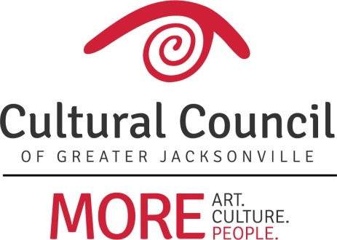

Demographic Chart - CSGP 2018-2019

Name of Organization: ___________________________________________

INSTRUCTIONS:
Compile demographic survey responses into this demographic chart. Provide numbers and percentages for board and staff for each category from the demographic surveys. Include number/percentages of any who did not provide a response.

Keep the individual survey responses as backup documentation. While responses may be anonymous, please double-check sums and percentages, and ensure that you’ve accounted for all CURRENT staff and board members.

This chart will serve to provide information to address the following CSGP eligibility criterion: The organization shall have a broad base of community representation in management …

BOARD OF DIRECTORS:

___ Total number of board members allowed by organization’s bylaws
___ Current number of board members serving

STAFF:

___ Total number of staff positions
___ Current number of staff positions filled

DEMOGRAPHIC CHART:

Number BOD | Percentage BOD | Demographic Category – Race | Number Staff | Percentage Staff | Duval County Census
 |  | White
 |  | African American/Black
 |  | Asian
 |  | Native Hawaiian/Other Pacific Islander
 |  | American Indian/Alaskan Native
 |  | Two or More Races
 |  | Did not respond
 |  | TOTALS
Number BOD | Percentage BOD | Demographic Category - Ethnicity | Number Staff | Percentage Staff | Duval County Census
 |  | Non-Hispanic/Latino
 |  | Hispanic/Latino (of any race)
 |  | Did not respond
 |  | TOTALS
Number BOD | Percentage BOD | Demographic Category – Gender | Number Staff | Percentage Staff | Duval County Census
 |  | Male
 |  | Female
 |  | Did not respond
 |  | TOTALS
 |  | Demographic Category - Age |  |  | Duval County Census
 |  | Under 18
 |  | 18-44
 |  | 45-64
 |  | 65 and older
 |  | Did not respond
 |  | TOTALS
Number BOD | Percentage BOD | Demographic Category – Geographic Representation - RESIDENCE | Number Staff | Percentage Staff
 |  | Beaches
 |  | Arlington
 |  | Northside
 |  | Westside
 |  | Northwest-side
 |  | Southside
 |  | Mandarin
 |  | Urban Core (Downtown, Springfield, San Marco, Riverside/Avondale)
 |  | NE Florida County (Clay, Nassau, St. Johns, Baker)
 |  | *Other
 |  | TOTALS
Number BOD | Percentage BOD | Demographic Category – Geographic Representation - BUSINESS | Number Staff | Percentage Staff
 |  | Beaches
 |  | Arlington
 |  | Northside
 |  | Westside
 |  | Northwest-side
 |  | Southside
 |  | Mandarin
 |  | Urban Core (Downtown, Springfield, San Marco, Riverside/Avondale)
 |  | NE Florida County (Clay, Nassau, St. Johns, Baker)
 |  | *Other
 |  | TOTALS

*If there are any geographic representation responses for “other,” please list locations represented here:

