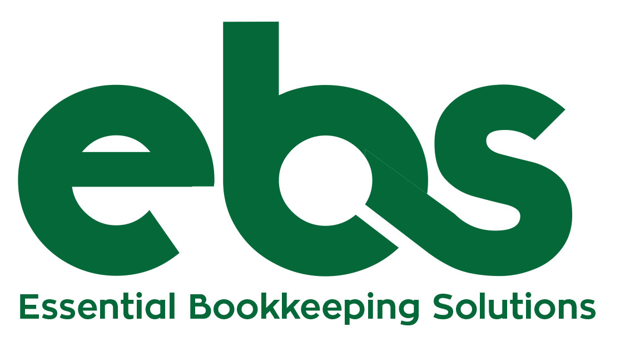
Prepared by:
Dawn Brady

Prepared for:
Cultural Council of Greater Jacksonville
Accounting Services Proposal
Project Description

Essential Bookkeeping Solutions, LLC (“the firm”) is an accounting practice located at 1929 Park Avenue, Orange Park, FL 32073, willing and ready to provide accurate and efficient accounting services to its clients. From payroll processing, accounts receivables, financial statement preparation, to other financial reporting, the firm shall readily provide.

The firm shall assess the client’s past financial reports and make a work plan befitting the nature and orientation of the client company.

TABLE OF CONTENTS

Executive Summary | 3
Proposing Company at a Glance | 4
Qualifications
Personnel
Cost Estimate | 5
Contract Terms | 6
Services
Confidentiality
Contract Termination

Executive Summary

In today’s competitive economic sector, nonprofit owners and officers (“you”) are seeking a higher level of competence, which is why Essential Bookkeeping Solutions, LLC ensures that it employs only the best, most competent accountants who can help you properly record and maintain the liquidity of your nonprofit assets, for your convenience.

Goals

The firm aims to provide you a clear picture regarding the liquidity of your company’s finances by way of the following:

- Providing a reliable and efficient accounting support for your nonprofit by assisting you in your accounting needs;

- Imposing an improved administrative control over finances and accounting processes;

- Ensuring reliability of data by imposing systematic record-keeping process regarding the financial information of the company;

- Issuing monthly reports of financial expenditures and disbursements; and

- Contributing to the stability of the company by giving regular reports and financial predictions to sustain liquidity of its assets.

Solutions

Accounting is an important aspect of nonprofits and helps you keep track of your finances and ensure liquidity of assets. Startup companies and established names in the industry alike can benefit from hiring accounting firms, as studies have shown that outsourcing these services can lessen nonprofit costs. Essential Bookkeeping Solutions, LLC takes pride in its ability to provide your company with efficient financial solutions and accounting needs.

Proposing Company at a Glance

Qualifications

Essential Bookkeeping Solutions, LLC has been providing accounting solutions since 2008 from its head office at 1929 Park Avenue, Orange Park, FL. The firm focuses on efficient recording, classifying, summarizing, and decision-making services that ensure the stability and financial health, as well as the increased profitability of its client companies.

The firm is divided into several teams, each of which is headed by a Team Leader hand-picked to give proper attention to his or her assigned clients. Essential Bookkeeping Solutions, LLC is dedicated to delivering its job, assuring all prospective clients of its efficiency and capability.

Personnel

Essential Bookkeeping Solutions, LLC shall provide Cultural Council of Greater Jacksonville with an efficient and dependable accounting team that will help establish liquid financial accounts.

TEAM | CREDENTIALS
Dawn Brady | Over 25 years accounting experience, Accounting degree, 12 years in nonprofit accounting, QuickBooks ProAdvisor
Talitha Mitchner | 8 years of Accounting experience, Accounting degree, Enrolled Agent’s License
Jack Klees | Over 30 years accounting experience, Master’s in Accounting, 25 years of nonprofit accounting. Jack will provide oversight for audit control and financial reporting.

Cost Estimate

Below are details regarding cost estimates of the services to be provided by Essential Bookkeeping Solutions, LLC

INITIAL ACCOUNT FEES | ESTIMATE COST FEES
Weekly bookkeeping which includes:  - Accounts Payable – approximately 2-3 hours/week  - posting/paying payables  - printing checks  - updating W-9 forms  - mailing the checks  - Accounts Receivable – approximately 2-3 hours/week  - posting invoices/payments for Grants  - posting deposits  - taking deposits to the bank  - Grants – approximately 6-8 hours per week  - Assist with the preparation, narrative, budget, etc. and submission for various Grant applications – DOS, License Plates, COJ, CARES, etc.  - Administrative/HR duties – 2-4 hours /week  - Assist staff with login retrievals from IT company  - Call Insurance companies to setup/add/change/fix old or current insurance choices  - Assist staff with scanned document retrievals  - Assist staff with various IT requests  - Assist staff with various HR requests  - Semi-monthly payroll – approximately 1 hour/month  - Post salary to SurePayroll website  - Update any PTO, Insurance, 401k, tax withholding, etc. employee update in their employee profile  - Post payroll in QuickBooks per the Grant report | 71 hours/month  $5,325
Monthly and Quarterly Reports – approximately 3-4 hours/month  - Financial Statements  - Dashboards  - Key Performance Indicator reporting  - Budget reports | 3 hours/month  $225
Additional Services/Reporting | Upon Request
Total: | $5,550

The above quotation is based upon estimates and anticipated cooperation from the personnel of Cultural Council of Greater Jacksonville. The firm understands the importance of maintaining administrative costs; hence, the quoted fees shall be discussed in detail.

Contract Term

The contract term is for 888 hours/year. Hours can be used as described above or can be swapped and used a la carte in place of other services. For example, instead of mailing checks or taking the deposit to the bank or posting Qgiv donations, those hours can be used for advanced reporting or staff training.

- The 888 hours/year (74 per month on average) can be used as a bank of hours for your organization to utilize as best it deems fit – up to and including the total allotted hours (888) in a year.

- Once the bank of time is used up, an adjustment to your hours can be discussed with the firm, or you can choose to be billed at an hourly rate.

Either party may cancel with 30 days written notice.

This quotation does not include the computation of payroll, as SurePayroll, a third-party payroll service, is utilized by Cultural Council of Jacksonville to perform this function.

- Cultural Council of Jacksonville has total control over their SurePayroll account – just as it would over any other third-party payroll service. There is a portal for the payroll administrator and approver to login to for the payroll service days.

However, this quotation does include the posting of payroll, as this needs to be done in accordance with grant fund specifications and requires closer scrutiny to remain in compliance.

Best regards,

Dawn Brady
President
Essential Bookkeeping Solutions, LLC

