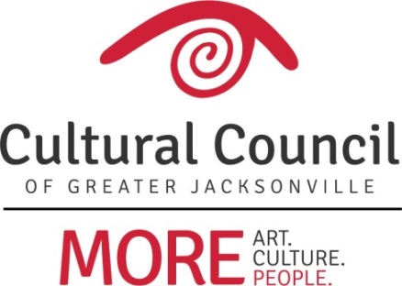

Cultural Service Grant Program (CSGP) Report – February 15, 2018

CSGP Committee

Three new CSGP Committee members have been nominated under the auspices of the Governance Committee in its noticed meetings through the process proscribed in the revised ordinance:

The Cultural Council shall be responsible for establishing an annual Cultural Service Grant Program (CSGP) Committee. The Composition of the CSGP Committee shall include one non-voting and ten voting members: a CSGP Committee chairperson (non-voting), appointed by the President of the Cultural Council Board of Directors; three other Cultural Council Board members selected by the Board President and Committee Chairperson; and seven individuals selected by the above group (Cultural Council Board President, CSGP Committee chairperson, and three selected Cultural Council Board members) from a pool of nominations established through a community wide nomination process. The Cultural Service Grant Committee shall have a liaison relation with one member of City Council and one representative of the Mayor's Office.

The nominees for appointment are:
- Jannet Walker Ford (Board Representative) – replacing Ann Carey
- Anne Lufrano (Community Representative) – replacing Beth Harvey
- Dave Faliszek (Community Representative) – replacing Frank Watson

2018-2019 CSGP Letter of Intent

The deadline for organizations to submit a Letter of Intent to the 2018-2019 Cultural Service Grant Program is February 27.

