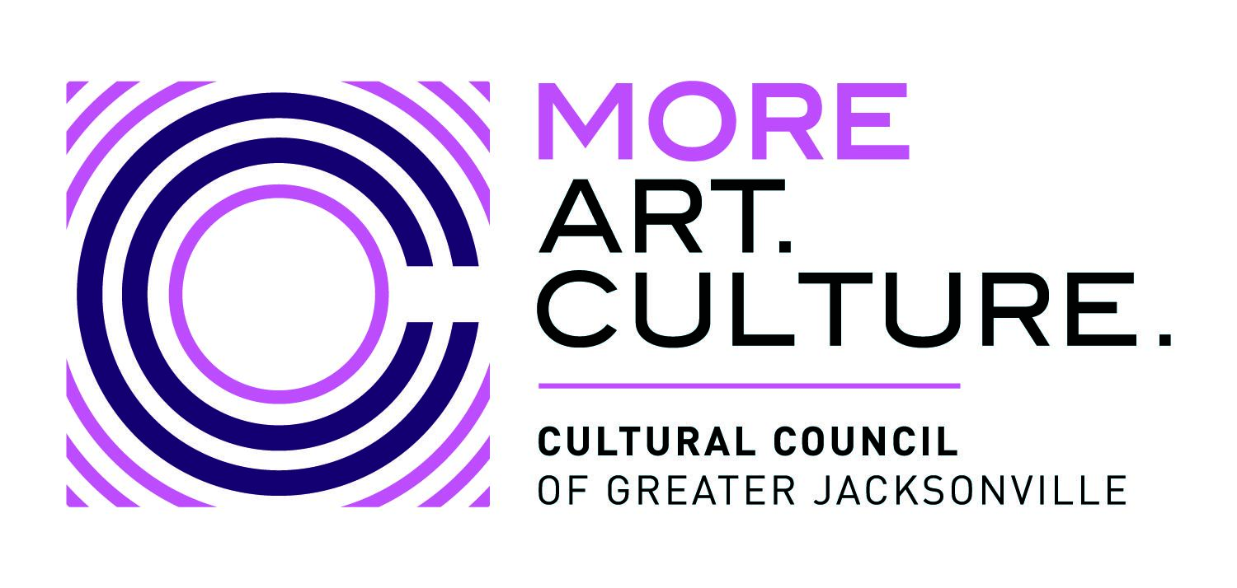
Board of Directors Meeting Agenda
Thursday, Oct. 19, 2023 4:00 PM – 6:00 PM ET
Jessie Ball duPont Center Room 318, 40 E Adams St, Jacksonville, FL 32202
Zoom Meeting Link: https://us06web.zoom.us/j/84935405213
Phone Number: (US) +1 305 224 1968 Meeting ID: 849 3540 5213
□ Ari Jolly, Board Chair □ Kat Hardwick, Director
□ Lisa Johnson, Vice Chair □ Chris Lazzara, Director
□ Ryan Ali, Director □ Laura Schepis, Director
□ Dr. Jennifer Brown, Director □ Dr. Timothy Snyder, Director
□ Kirsten Doolittle, Director □ Jeff Strohecker, Director
□ David Faliszek, Secretary □ The Honorable Jimmy Peluso, City Council Liaison
□ Karen Feagins, Director □ The Honorable Angie Nixon, Florida House Representative
□ Ashley Folladori, Director
□ Michael Freed, Director

IMPORTANT NOTE: An in-person quorum of 50% +1 of voting members is required to take any action on motions. The work of the Cultural Council Board of Directors requires motions to be made in order for business to move forward.

A. Welcome & Call to Order, Chair Ari Jolly 4:00 PM
The meeting was called to order at 4:15pm once it was clear that a quorum was present.
B. Roll Call, Chair Ari Jolly 4:00-4:02 PM
C. Approval of Consent Agenda, Chair Ari Jolly 4:02-4:04 PM
- Board: 4-20-23
- CSGP: 6-7-23, 6-29-23, 7-20-23
- APPC :4-12-23, 8-9-23, 9-13-23
- Governance: 4-6-23, 6-12-23, 8-15-23
- Proposed Motion for Consent Agenda: “Motion to approve the consent agenda.”
The motion was so moved and all were in favor of approving the consent agenda
D. Chair’s Report, Chair Ari Jolly 4:04- 4:10 PM
Chair Jolly provided her comments and acknowledged the Fiscal Year 2023 was a successful year for the organization. This would be her last meeting as Chair and she thanked all the Board members for their contributions and was grateful for having served with such an outstanding Board. She further acknowledged the hard work and achievements of the staff and wished the organization continued success.
E. Approval of FY2024 Cultural Service Grant Program operating awards
Amy Palmer, Director of Grant Administration 4:11-4:20 PM

Amy provided a review of the Cultural Service Grant Program and the plan for determining grant award amounts for the new Fiscal Year. She explained how the awards would be reviewed and approved especially in light of the increase in the award by the City.

- Proposed Motion: To approve the FY2024 Cultural Service Grant Program operating awards as certified and recommended by the CSGP Committee during its hearings held on Oct. 3.
The motion was so moved and all present agreed with the approval.
F. Committee Reports
- Governance Committee, Vice Chair Lisa Johnson 4:20-4:40 PM
Vice Chair Lisa Johnson led the discussion of the proposed changes to the FY2024 board and officer slate.
  - Proposed Motion: To approve the following FY2024 board officer slate, as recommended by the Governance Committee:
    - Chair: Lisa Johnson
    - Vice Chair: Laura Schepis
    - Secretary: Tim Snyder

The motion was moved and seconded and all present approved the new slate of officers.

Vice Chair Lisa Johnson led a brief discussion regarding the motion to approve Joey Greive for a position on the board and appointing him as Treasurer and Finance Committee Chair.

  - Proposed Motion:
    - 1st MOTION: To approve Joey Greive as an elected board member
    - 2nd MOTION: To approve Joey Greive for the board office of Treasurer and Finance Committee Chair

The motions was moved, seconded and all present approved the motions.

- Finance Committee: Interim Finance Committee Chair Lisa Johnson, Diana Donovan
& Nan Kreamer 4:41-5:10 PM

Interim Finance Committee Chair Lisa Johnson, Diana Donovan and Nan Kreamer presented the financial results for the Fiscal Year 2023 and the Draft Budget for Fiscal Year 2024. A discussion ensued and all Board members acknowledged they had sufficient information to move forward with the motion to approve.

  - Proposed Motion: To approve the Cultural Council’s FY2024 operating budget and close the books on FY2023, as recommended by the Finance Committee
The motion was so moved, seconded and all were in favor of approving the FY2024 operating budget as presented. Further, all were in favor of closing the books for FY2023.
G. Executive Director & Senior Leadership Team Reports 5:11-5:50 PM
- Grants Department Update: Amy Palmer, Director of Grant Administration
- APP Department Update: Kat Wright, Director of Art in Public Places
H. Upcoming BOD Meeting Dates, Vice Chair Lisa Johnson 5:51-5:55 PM
- NEW DATE: Thursday, January 25, 2024 from 4:00-6:00 PM
- Thursday, April 25, 2024 from 4:00-6:00 PM
- Thursday, August 15, 2024 from 4:00-6:00 PM
- Thursday, Oct. 17, 2024 from 4:00-6:00 PM
I. Public Comment, Chair Ari Jolly 5:55-6:00 PM
There was no public comment at this meeting
J. Adjournment, Chair Ari Jolly 6:00 PM
Chair Ari Jolly acknowledged this was her last meeting as Chair and she passed the gavel to the incoming Chair, Lisa Johnson. The meeting was then adjourned.

