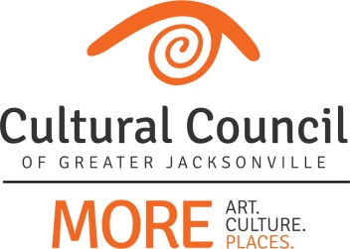

ART IN PUBLIC PLACES COMMITTEE
Meeting Agenda
December 14, 2016
Cultural Council Conference Room
Times Union Center for the Performing Arts
300 W. Water St. Ste. 201, Jacksonville, FL 32202

Invitees: David Engdahl, Mary Harvey, Lea Mahan, Christina Parrish, Sandra Hull Richardson, JaMario Stills, Nominees: Tracie Thornton; Mico Fuentes, Suzanne Pickett, Cory Driscoll
Invited Guests: CCGJ Staff
------------------------------------------------------------------------------------------------------------------------------------------

- Call to Order – Dave

GUEST PRESENTATION
- Sharla Valeski 12:00pm-12:05pm

ACTION ITEMS
- Items to consider approval of: 12:05pm-1pm
  - November meeting minutes
  - DIA Urban Arts Project – Phase 1 Art Selection Panel recommendations

OLD BUSINESS

- Project updates 1pm-1:15pm

NEW BUSINESS
- Liberty Street Public Art removal, storage, reinstall 1:15pm – 1:25pm

IMPORTANT DATES:
Every Single Artist Lounge: January 12, 2017, 5-6:30pm (The Volstead)
Next APPC meeting: January 11, 2017, 12-1:30pm (CCGJ Conference Room)

PUBLIC COMMENT 1:25pm-1:30pm

Adjournment

