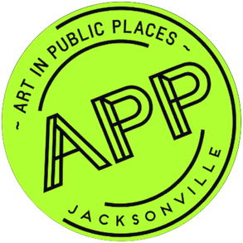

Art in Public Places
Cultural Council Board Meeting
January 17, 2019

- The Neighborhoods Public Art projects launched on January 9, 2019 with Calls to Artists for Cuba Hunter Park, Legends Community Center and Winton Drive. The deadline for qualifications submissions is February 9, 2019. Local artists are encouraged to team-up.

- The Conservation review and design revisions are in progress for DIA Phase 2 The Art Selection Panel (ASP) will make recommendations to the APP Committee on February 13 2019.

- Three Water Street Parking Garage semi-finalists will submit initial concept designs by February 6, 2019. The ASP will award one finalist in mid-February. Date TBD.

- Evergreene Architectural Arts has been selected to provide conservation services for 24 priority 1 and 2 public artworks and memorials. Contract negotiations are in progress. On-site assessments begin late February.

- Four UNF students are participating in the APP Internship Program for this spring semester.

- The 2019 APP Annual Plan and Schedule is on the CCGJ website at:
http://www.culturalcouncil.org/uploads/9/3/6/9/93693002/app_annual_plan_2019_and_schedule.pdf

