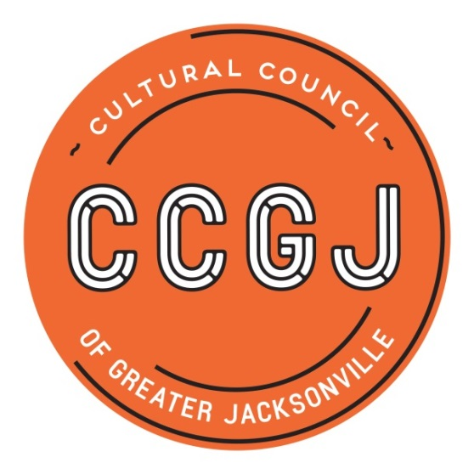

2019-2020 Cultural Service Grant Committee

Anne Boccuzzi (board rep)

David Faliszek (comm rep)

Sandra Hull-Richardson (comm rep)

Truitte Moreland (comm rep)

Richard Naylor (comm rep)

Ben Rubin (comm rep)

Jannet Walker Ford (board rep)

TBA
Chair
Board Rep (1)
Community Rep (2)
Liaison - City Council Representative
Liaison - Mayor’s Office Representative

