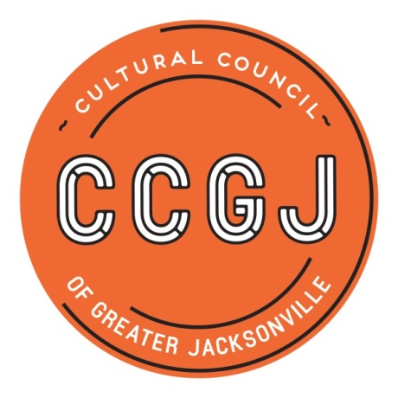

2018-2019 CSGP Compliance Workshop: Wednesday, Dec. 12, 2018, 10 a.m.-noon, @ WJCT

Welcome!
- Introductions and Housekeeping

Misc.
- New Executive Director of Cultural Council - Joy Young
- Cultural Council Communications - Jihan Grant
- Arts Awards - Chelsey Cain
- 2019-2020 CSGP LOI & Process Timeline
- Help Sessions & Networking
  - Pilot “Office Hours” – Thursday, Jan. 10, 9 a.m.-noon @ Cultural Council
    - Available to assist with CSGP follow-ups due Jan. 15
- CSGP Process Evaluation
- Contact Info Changes
- CSGP Committee

CSG Compliance
- Foundant
- Compliance Timeline
- Follow-up Items Review

Questions?
- Amy Palmer – apalmer@culturalcouncil.org; (904)358-3600 x14
- Chelsey Cain – chelsey@culturalcouncil.org; (904)358-3600 x19
- Cedric Lewis – cedric@culturalcouncil.org; (904) 358-3600 x16
- Jihan Grant – jihan@culturalcouncil.org; (904) 358-3600 x17

