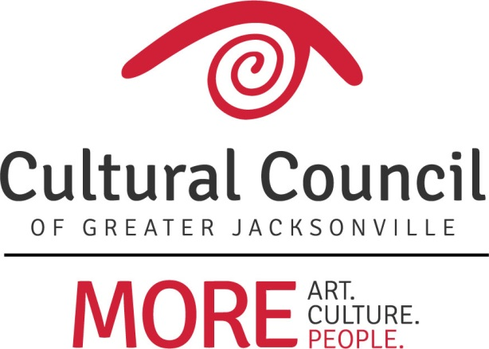

2017-2018 CSGP Compliance Workshop: Wednesday, Dec. 6, 2017, 10 a.m.-noon, @ TUCPA

Welcome!
- Introductions and Housekeeping

CSG & Other Misc.
- CSGP Advocacy
- CSGP Member’s Only Website
- 2018-2019 LOI
- CSGP Committee
- Contact Info

CSG Compliance
- Why Compliance?
- Compliance Items and Deadlines
- Additional Guidance

Questions?
- Amy Palmer – apalmer@culturalcouncil.org; (904)358-3600 x14
- Chelsey Cain – chelsey@culturalcouncil.org; (904)358-3600 x19
- Tony Allegretti – tony@culturalcouncil.org; (904) 358-3600 x18
- Patrick Fisher – patrick@culturalcouncil.org; (904) 358-3600 x17
- Cedric Lewis – cedric@culturalcouncil.org; (904) 358-3600 x16

