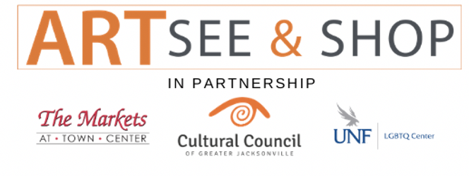
FOR IMMEDIATE RELEASE
Contact: Ellen Cottrill
Communication Coordinator
Cultural Council of Greater Jacksonville
904-699-7879
ellen@culturalcouncil.org

LOCAL ART & CULTURAL ENGAGEMENT GALLERY WILL STAY OPEN AT THE MARKETS AT TOWN CENTER
ARTSee & Shop will remain open through March
JACKSONVILLE, Fla. – January 26, 2021 - The Cultural Council of Greater Jacksonville is pleased to announce that ARTSee & Shop, the second annual pop-up art and cultural engagement gallery at the Markets at Town Center, will remain open through March, 2021. This year’s gallery is a unique collaboration between The Cultural Council of Greater Jacksonville, The UNF LBGTQ Resource Center, and the Markets at Town Center. The beautiful 5600 square foot gallery displays the work of over 50 Jacksonville artists, we well as a permanent exhibit by the UNF LGBTQ Resource Center. The gallery is generously sponsored by HINES, the parent company of the Markets at Town Center.

ARTSee & Shop was originally slated to be open as a holiday pop-up during the months of November and December. However, due to the success of the gallery, and the positive impact on the community, Hines has generously agreed to sponsor it for an additional three months.

The space was offered to The Cultural Council of Greater Jacksonville and the UNF LGBTQ Resource Center as part of the Hines’ Diversity and Inclusion Initiative. Together, they have created a space that beautifully displays the artwork and seamlessly incorporates a unique interactive “Closet Experience” that allows people to put themselves in the shoes of an LBGTQ+ person.

“We have planned several other programs and events that focus on art, culture, diversity,” said Ellen Cottrill, co-gallery director of ARTSee & Shop. “ Including the opening of the first ever WeaveTales exhibit, which brings the story of immigrants and refugees who have made their homes in Jacksonville; Coffee & Culture events to spark conversation and will include unique coffee and tea ceremonies from other countries, and exciting events to honor Black History Month and International Women’s Month.”

“The ARTsee & Shop gallery is a perfect extension of the Cultural Council’s mission,” said Diana Donovan, Interim Executive Director. “Bringing more art and culture to Jacksonville, while supporting the local economy and arts community. We are so appreciative to Hines and The Markets at Town Center for this phenomenal opportunity. We are honored to be able to offer this to the local artists and creatives in our community.”

In an effort to make the gallery financially sustainable, participating artists will be volunteering during opening hours.
The temporary gallery will also feature DIY workshops, book signings with local authors and team building events on Thursday afternoons. All events will be listed on our webpage and on our Facebook page.
Hours of operation are below:
Monday – Wednesday – By Appointment Only
Thursday – 11:00 – 5:30
Friday – Saturday 12:30 – 6:30
Sunday – 12:30 – 5:30

ARTSee & Shop is located at 4880-05 Big Island Dr, Jacksonville, FL 32246, across the parking lot from Cooper’s Hawk Winery.
####

